# Cover



E-Library

An Online Library Management System

   

By

|  |  |
| --- | --- |
| STUDENT1306302 | AMAAN AL MIR |
| STUDENT1119343 | AZAH ARIF ALI TAHA |
| STUDENT1400519 | ALA HAMID ABUBAKAR  MOHAMED ALHASAN |

# Table of Contents

Cover 1

Table of Contents 2

Certificate of Completion 7

Acknowledgement 8

Project Synopsis 10

Project Analysis 11

1. Objectives 11

2. System Modules 12

Guest Users 12

Registered Users 12

Administrator 13

3. Key Features 13

4. Challenges and Considerations 14

5. Conclusion 14

Application Design 15

Data Flow Diagram – Admin User 15

Activity Diagram – Account Registration 16

Use-Case Diagrams 17

1. Unregistered Users 17

2. Registered Users 18

3. Admin 19

Database Design & Structure 20

1. Users Collection 22

2. Categories Collection 23

3. Books Collection 24

User Guide 26

1. Register 27

2. Login 29

3. Homepage 30

4. Categories 31

5. Books & Videos 32

6. Search 33

7. Book Details 34

8. Read a Book Online 35

9. About & Contact pages 37

10. User Account 38

11. Website Administration 39

1. Dashboard 40

2. Manage Categories 41

Create New Category 41

Update/Delete a Category 42

3. Managing Books and Videos 44

Add New Book or Video 44

Update/Delete a Book or Video 45

4. Managing Users 46

12. Mobile & Tablet View 47

Developer Guide 48

Technology Stack 48

How To Run the Application? 50

Prerequisites 50

Method 1 50

Method 2 51

Source Code 52

Website Structure 52

1. Homepage 53

2. Registration 54

3. User Login 56

4. Password Recovery 58

4.1. Mail 58

4.2. Reset Password 59

5. Categories 60

6. Books 61

7. Book Details 61

7.1. Download 62

7.2. Updating Book Stats 62

8. User Account 63

9. Website Administration 64

9.1. User Permissions 64

9.2. Role Authorization 65

9.3. Insert Records 66

9.4. Update Records 68

9.5. Delete Records 69

9.6. View Records 69

References 70



# Certificate of Completion

This is to certify that the E-Library Team has satisfactorily completed the e-Project organized by Aptech. The program, conducted from November 8, 2023, to November 27, 2023, encompassed Web Application Development. Throughout the duration of the program, the E-Library Team demonstrated dedication, proficiency, and commitment to learning, successfully acquiring the essential knowledge and skills. This certificate attests to their diligence and successful fulfillment of all requirements as stipulated in the e-Project.

Issued this November 26, 2023.

Mr. Ashish Jha

Aptech Qatar

# Acknowledgement

We would like to express our heartfelt gratitude to the individuals and organizations who played a crucial role in the successful completion of this project. Each team member's dedication and collaborative spirit have contributed to the project's overall success.

Our gratitude goes to Mr. Ashish Jha for his guidance, support, and mentorship. His expertise and encouragement have been instrumental in steering the team in the right direction.

We are also thankful to Aptech Qatar for providing the necessary resources, facilities, and a conducive environment for teamwork and project development.

We express our thanks to the authors and researchers whose work served as a foundation for our understanding of Web Application Development

Finally, we extend our thanks to anyone else who has supported the team in various ways. Your collective efforts have made a significant impact on the project's success.

Thank you all for your dedication, hard work, and collaborative spirit. This project would not have been possible without each and every one of you.

* E-Library Team

# Project Synopsis

The E-Library project aims to streamline library management through an Online Library Management System. The system automates maintenance of book information, author details, member records, and library staff. This computerized solution reduces manual workload for librarians, ensuring efficient maintenance and preventing data loss. The system encompasses modules for Guest Users to view available titles, Register Users to access features like online reading and downloads, and an Admin module for comprehensive management. Admin capabilities include overseeing book details, user registration, categories, and generating reports. With simplified access and robust features, E-Library enhances library management, providing a user-friendly experience for both administrators and library members.

# Project Analysis

The online library management system is designed to streamline and automate various operations related to book management, user registration, and administrative tasks. The manual complexities of managing a library are addressed through computerization, reducing the workload and enhancing overall efficiency.

## Objectives

* Automate book management, user registration, and library operations.
* Reduce manual workload for librarians.
* Ensure accuracy and security of book and user records.
* Provide convenient access to information for both guests and registered users.
* Enable online reading and downloading of books (if permitted by admin).
* Facilitate efficient management through an admin dashboard.

## System Modules

### Guest Users

* View available book titles.
* Make inquiries through the contact us page.
* Access general information about the library, including timings and book categories.

### Registered Users

* One-time registration for E-Library access.
* Login to access various features.
* Search for books based on different criteria.
* Read books online.
* Download books (if permitted by admin).
* Access video tutorials under different categories.
* Change their passwords for security.

### Administrator

* Superuser with comprehensive control over the system.
* Dashboard for an overview of books, registered users, and categories.
* Manage categories: Create, update and delete.
* Manage books and videos: Add, edit, and set download permissions.
* Manage users: update and delete

## Key Features

* Efficiency: Automation reduces manual work for librarians, making library management more efficient.
* Accuracy: Computerization ensures accurate maintenance of book and user records.
* Convenience: Users can access and manage library resources online, improving convenience.
* Security: User data and book records are secure and less prone to loss.
* User Engagement: Features like online reading, downloads, and video tutorials enhance user engagement.

## Challenges and Considerations

* Ensure data security and privacy.
* Implement effective search functionality for users.
* Regularly update and maintain the system for optimal performance.
* Provide adequate documentation and user support.
* Test the system thoroughly to identify and address any bugs or issues.

## Conclusion

E-Library aims to modernize and simplify library operations, benefiting both librarians and users. By incorporating user-friendly interfaces and robust administrative features, the system is poised to enhance the overall library experience in the digital age. Regular updates and user feedback will be essential to ensuring the ongoing success and relevance of the system.

# Application Design

## Data Flow Diagram – Admin User

Admin

Manage Categories

Manage Books

Manage Users

Create Category

Edit Category

Delete Category

Add Book/Video

Edit Book/Video

Delete Book/Video

Edit User

Delete User

## Activity Diagram – Account Registration

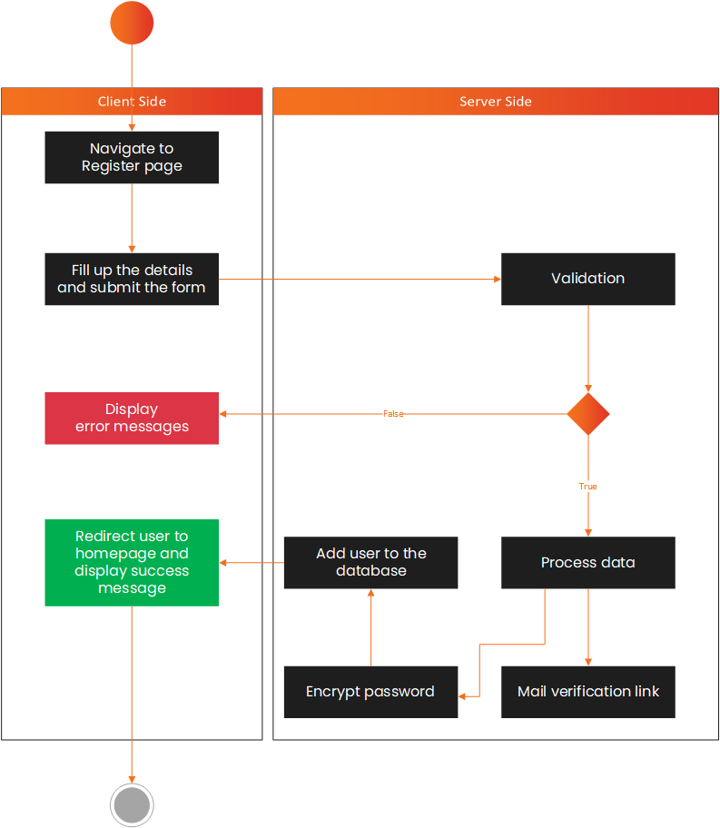

## Use-Case Diagrams

### Unregistered Users

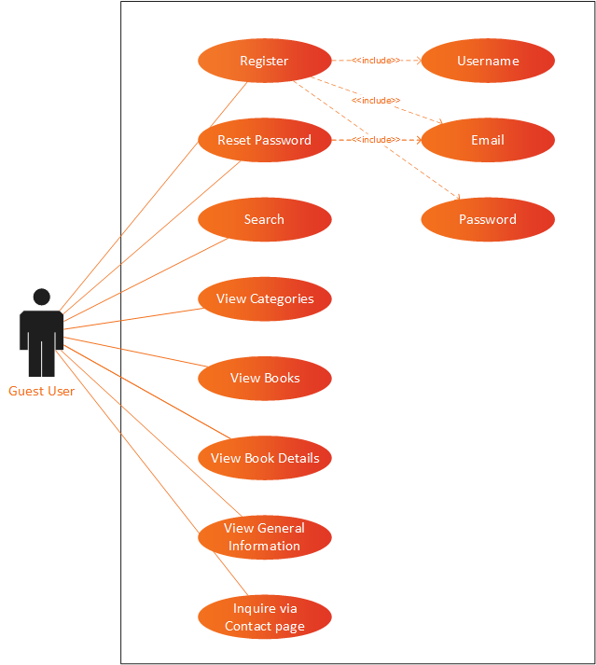

### Registered Users

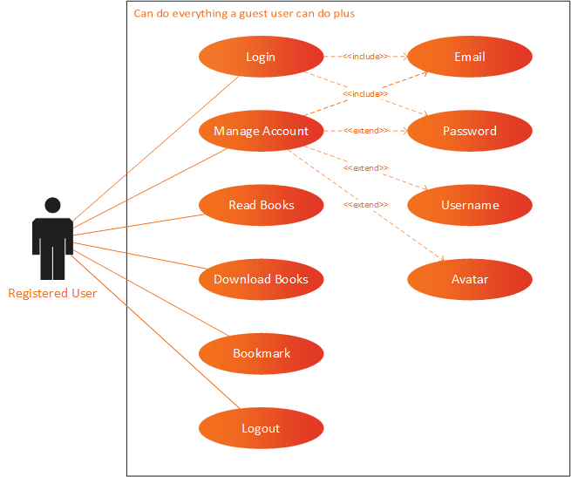

### Admin

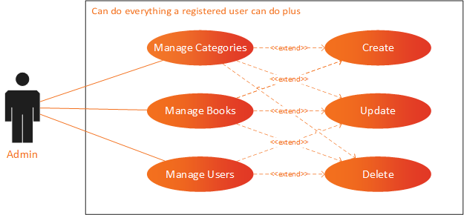

## Database Design & Structure

|  |  |  |
| --- | --- | --- |
| Collection | Field | Field Type |
| Users | _id | ObjectId |
| username | String |
| email | String |
| password | String |
| created_on | Date |
| verified | Boolean |
| avatar | String |
| token | String |
| updated_on | Date |
| roles | Array |
| bookmarks | Array |
| Categories | _id | ObjectId |
| category | String |
| icon | String |
| image | String |

|  |  |  |
| --- | --- | --- |
| Collection | Field | Field Type |
| Books | _id | ObjectId |
| type | String |
| category_id | ObjectId |
| title | String |
| year | Int32 |
| author | Array |
| publisher | String |
| summary | String |
| book | String |
| downloadable | Boolean |
| cover | String |
| video | String |
| view_count | Int32 |
| download_count | Int32 |

The MongoDB database for the E-Library web application is well-organized, consisting of three main collections: Users, Categories, and Books. Each collection captures essential information related to users, book categories, and individual books. Below is a summary of the key fields and their types in each collection:

### Users Collection

Fields:

* _id: Object ID for user identification. Auto generated.
* username: String representing the username.
* email: String for the user's email.
* password: String storing the user's password.
* created_on: Date indicating the user's registration date.
* verified: Boolean indicating whether the user is verified.
* avatar: String for storing the user's avatar.
* token: String for user authentication.
* updated_on: Date indicating the last update date.
* roles: Array storing user roles.
* bookmarks: Array storing bookmarked items.

Sample Data:

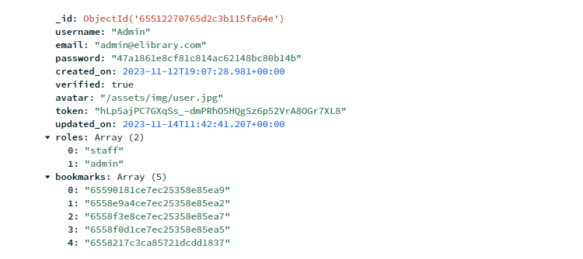

### Categories Collection

Fields:

* _id: Object ID for category identification. Auto generated.
* category: String representing the category name.
* icon: String for storing the category icon.
* image: String for storing the category image.

Sample data:

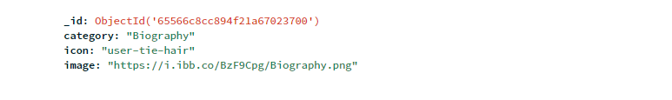

### Books Collection

Fields:

* _id: Object ID for book identification. Auto generated.
* type: String indicating whether the entry is a book or video.
* category_id: Object ID linking to the Categories collection.
* title: String representing the title of the book or video.
* year: Int32 indicating the publication year.
* author: Array storing author information.
* publisher: String representing the book publisher.
* summary: String providing a brief summary of the book or video.
* book: String for storing the book file (if applicable).
* downloadable: Boolean indicating if the book is downloadable.
* cover: String storing the URL for the book cover image.
* video: String storing the URL for the video.
* view_count: Int32 indicating the number of views.
* download_count: Int32 indicating the number of downloads.

Sample data:

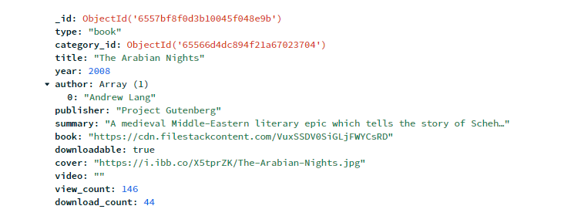

Key Observations:

* Relationships are established using Object IDs, linking different collections.
* Arrays are utilized for fields like authors, roles, and bookmarks to handle multiple values.
* Date types are used for tracking registration and update timestamps.
* Boolean types such as 'verified' and 'downloadable' provide binary information.
* Strings are utilized for textual data like usernames, emails, and text summaries.

This database structure is designed to efficiently manage user data, book categories, and individual books, providing a solid foundation for the E-Library web application. The use of MongoDB allows for flexibility and scalability as the application evolves.

(Anon., n.d.)

# User Guide

You can view the website online by going to:

|  |  |
| --- | --- |
|  | <https://elibrary.almir.info/> |

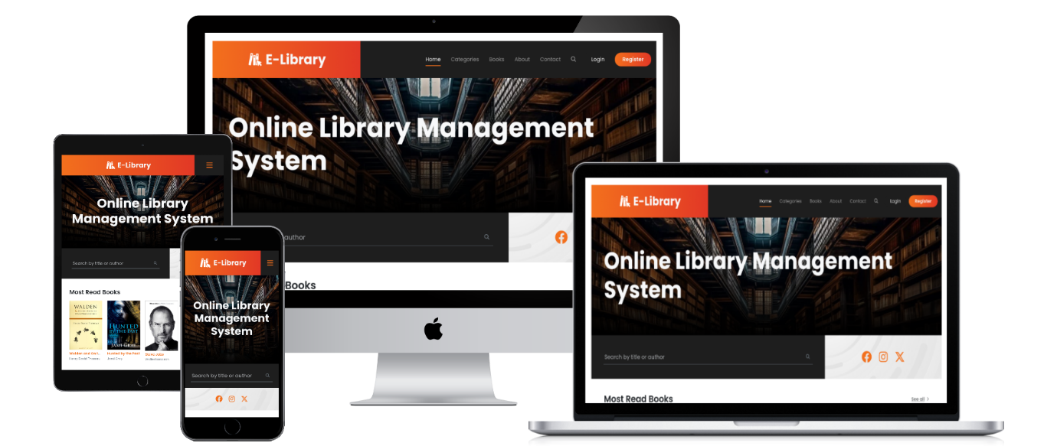

Video Demonstration:

Link: <https://www.youtube.com/watch?v=bo6WEnQ8j3g>

[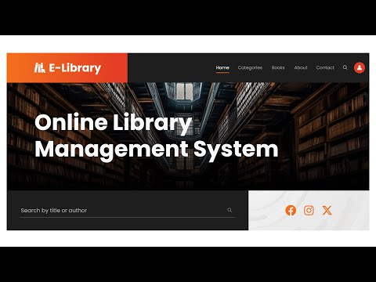](https://www.youtube.com/embed/bo6WEnQ8j3g?feature=oembed)

## Register

If this is first time visiting the website and you want to create an account, go to the register page by clicking on the Register button

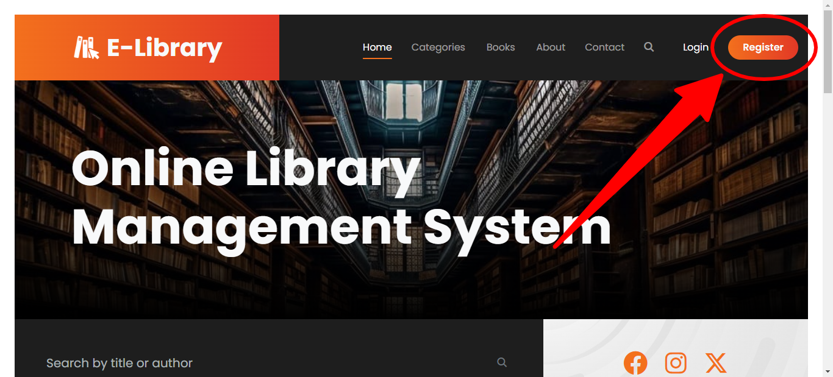

Fill in the details and click on the register to create a new account.

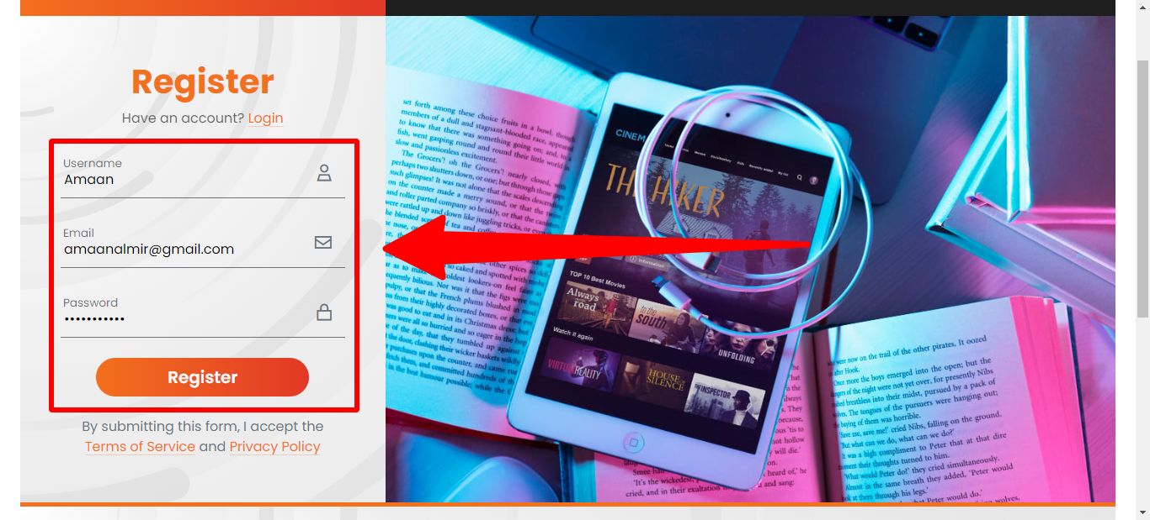

You may receive notifications if an error occurred while creating a new account.

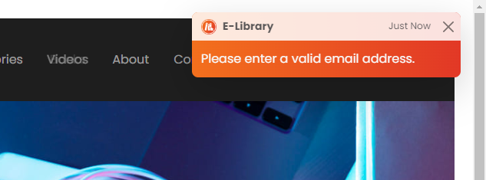

After successfully creating an account, you will receive an email to verify your email address. Check your mail to inbox and open the verification link to verify your email.

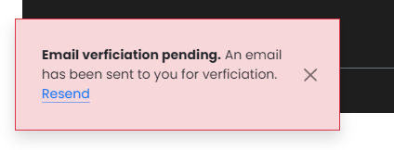

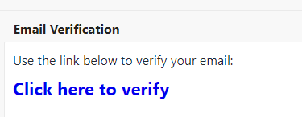

Upon clicking the verification link, your email address will be verified.

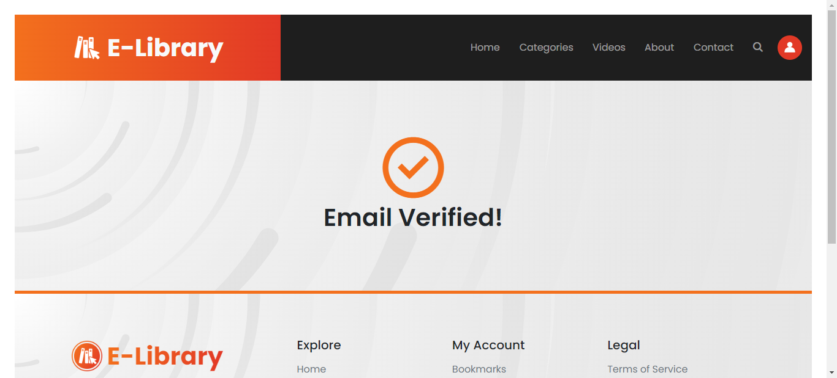

## Login

If you’re a returning user, you can use the login page to get into the website. Enter your email and p

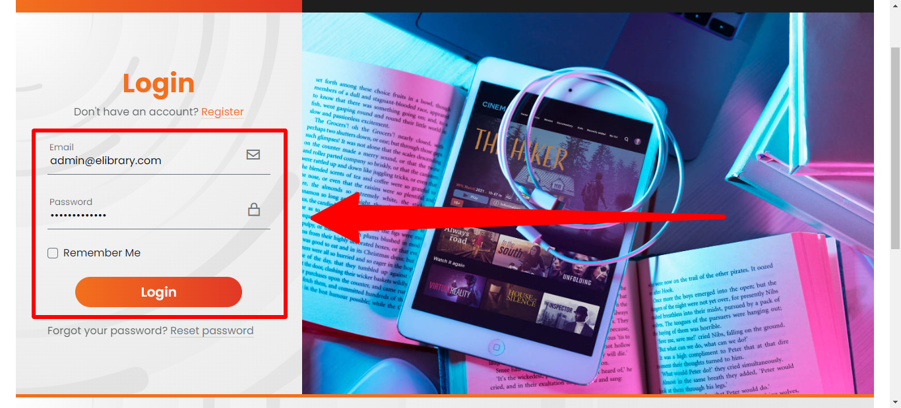

## Homepage

The home page displays some trending books and videos.

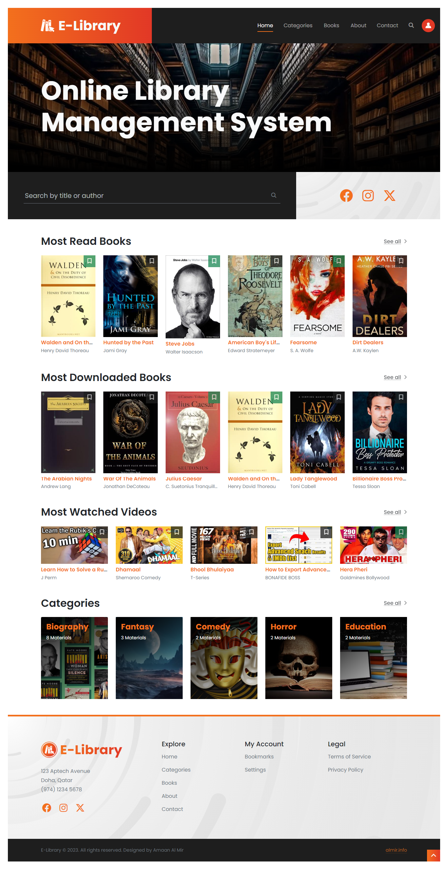

## Categories

On this page you can find a list of categories available.

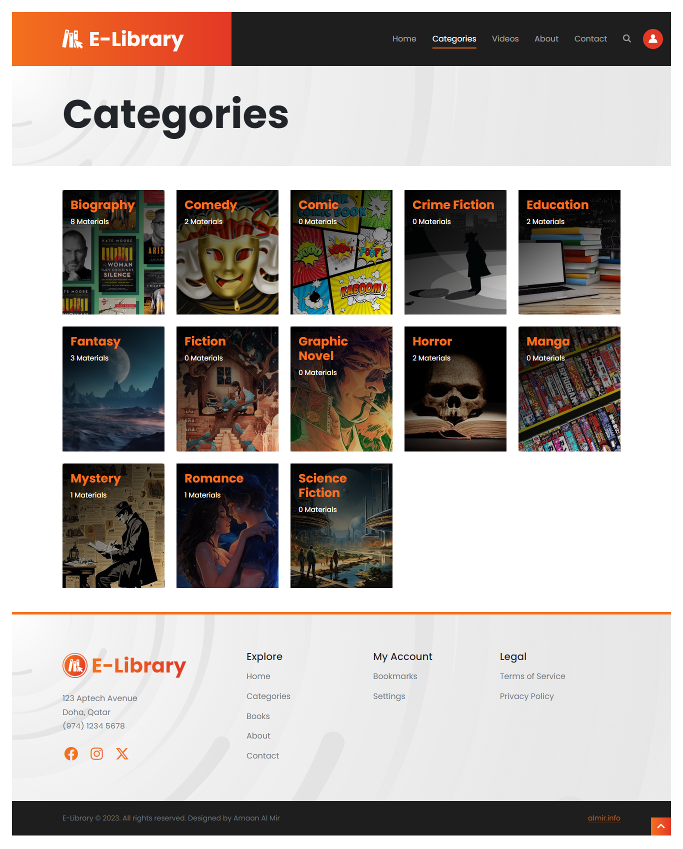

## Books & Videos

On this page you can find list of books and videos.

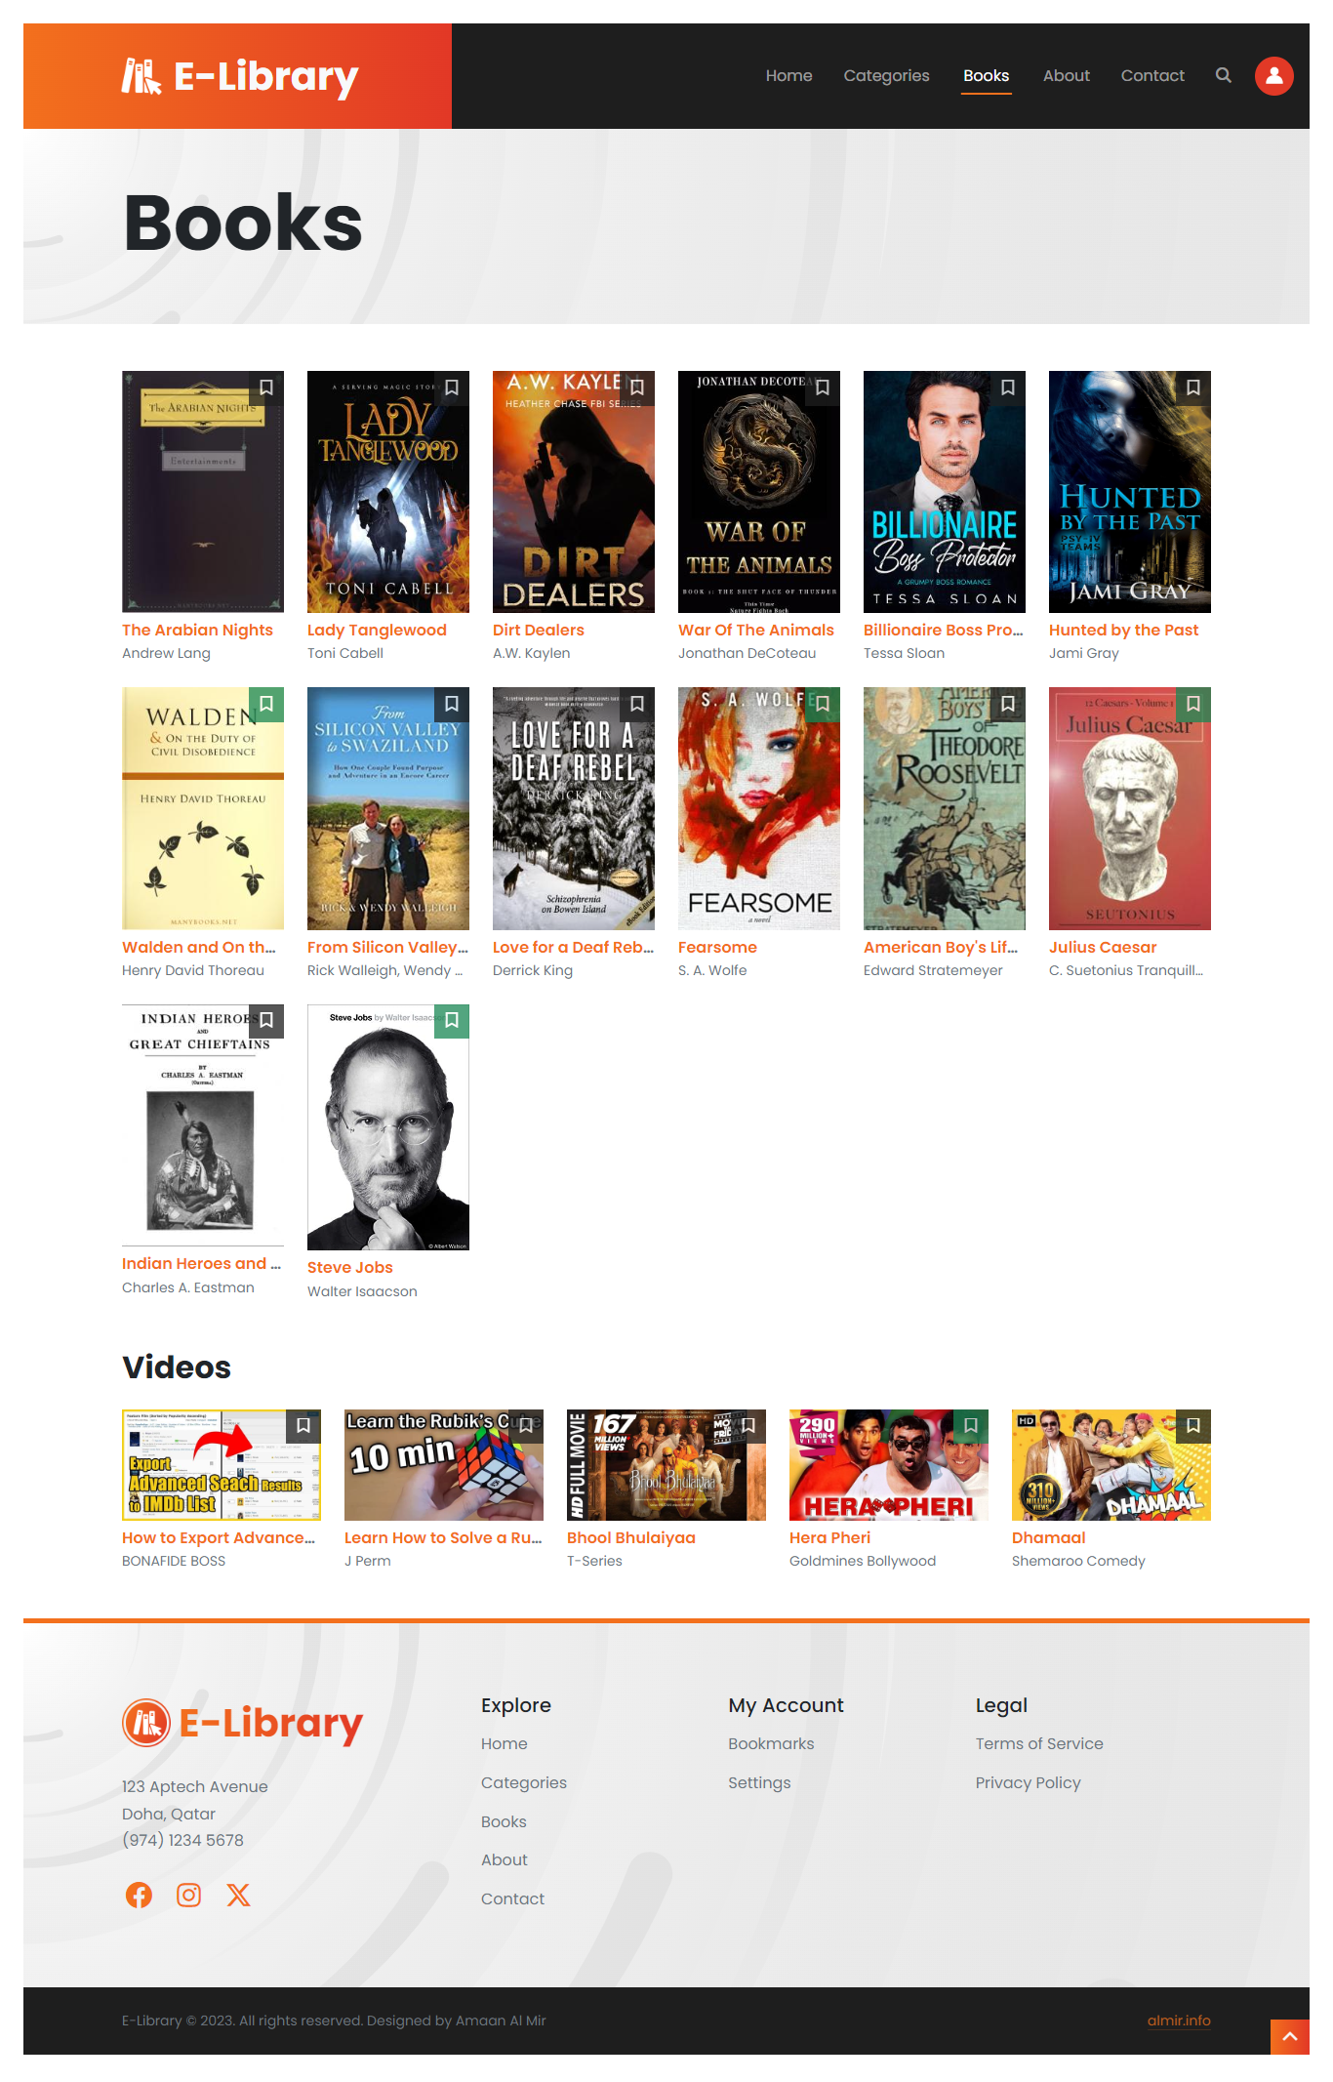

## Search

You can open the search menu from any page click on the search button given in the top navigation bar.

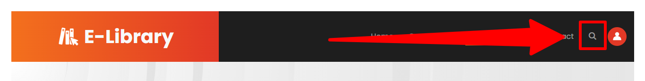

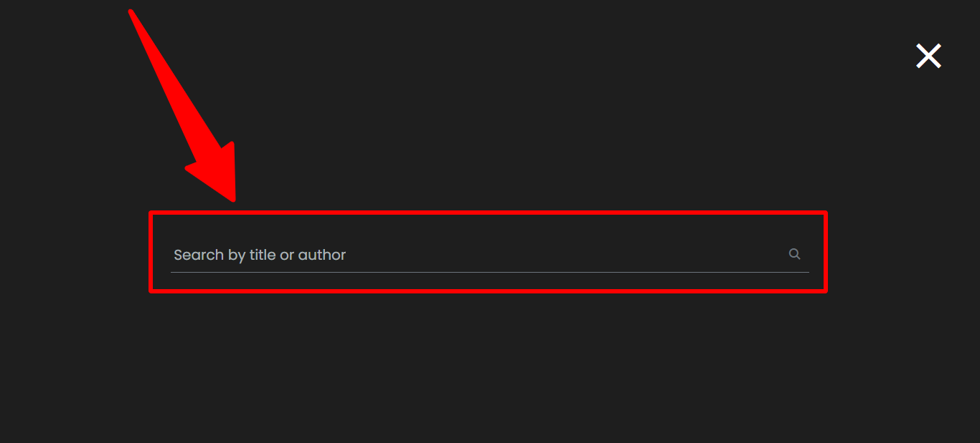

You can search for a book or a video by its title or author.

## Book Details

You can view any book or video details by clicking on it.

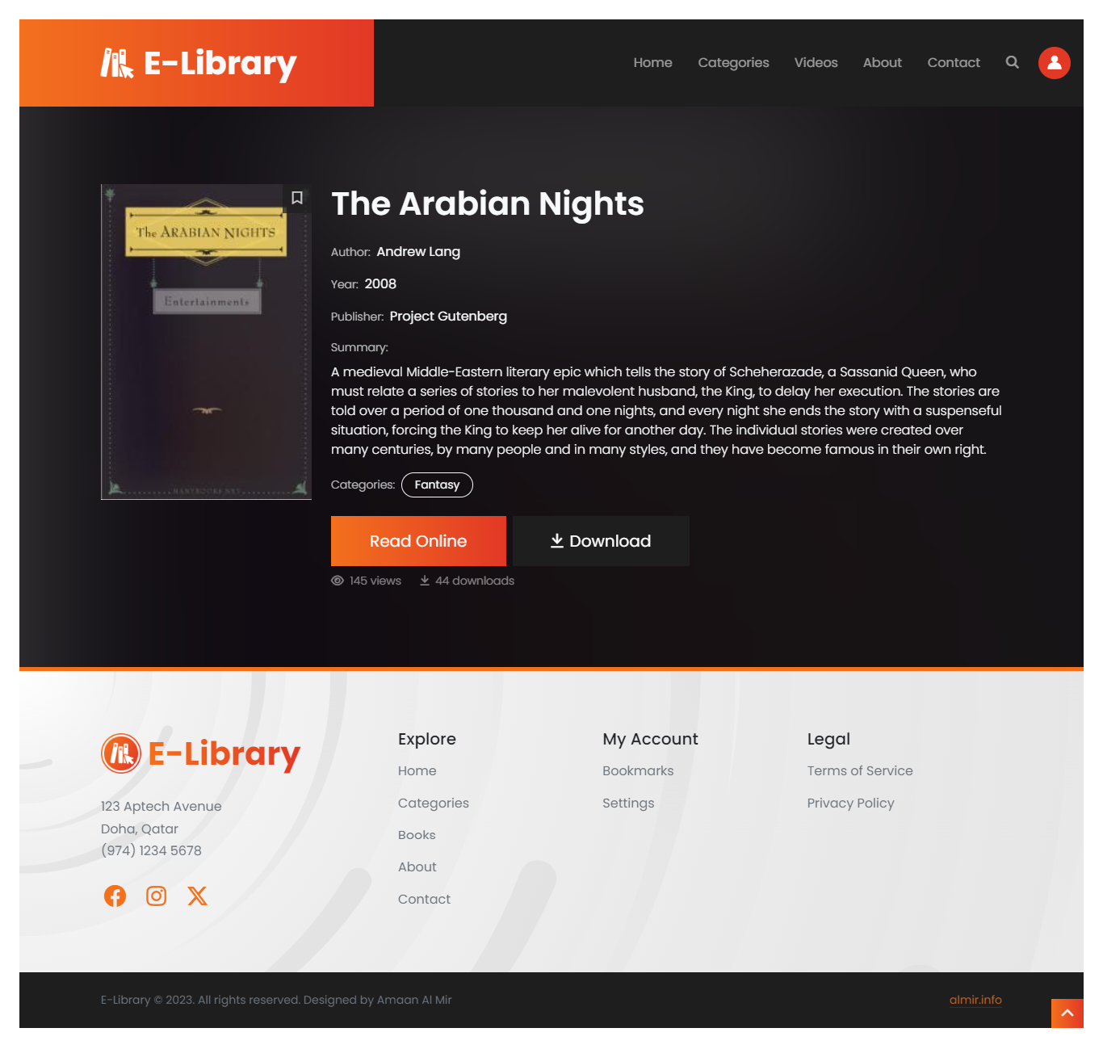

Note: Not all books can be downloaded.

## Read a Book Online

Non-logged in users will be asked to login before they can read the book online.

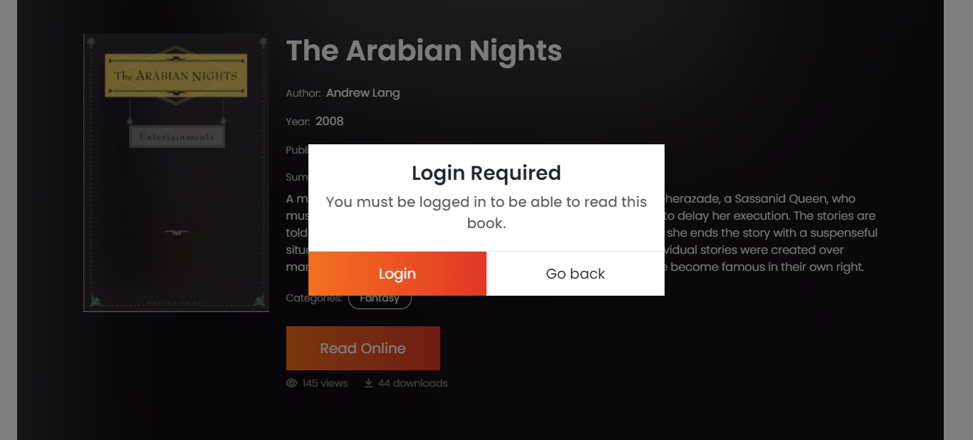

Logged-in users can click on the read button the read the book.

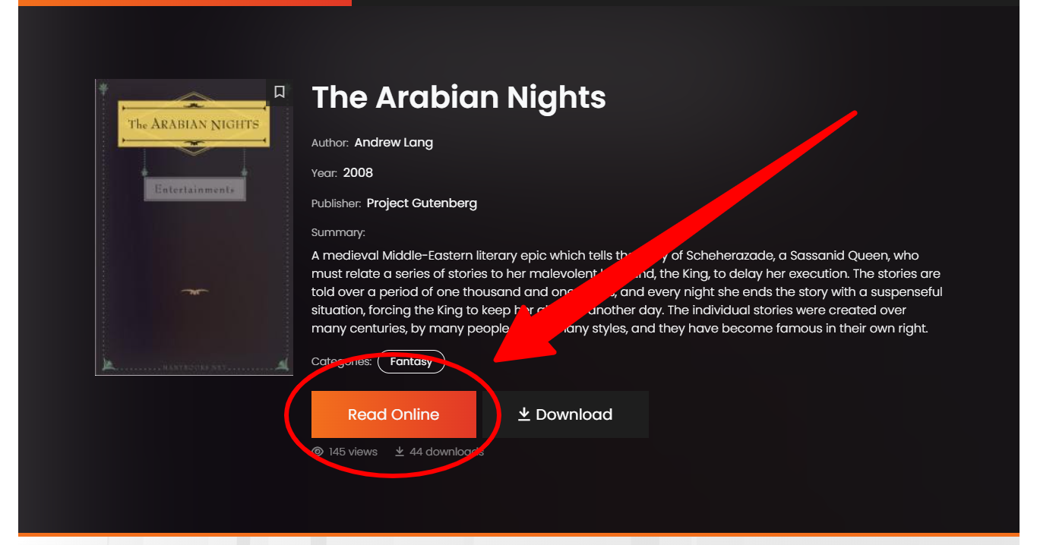

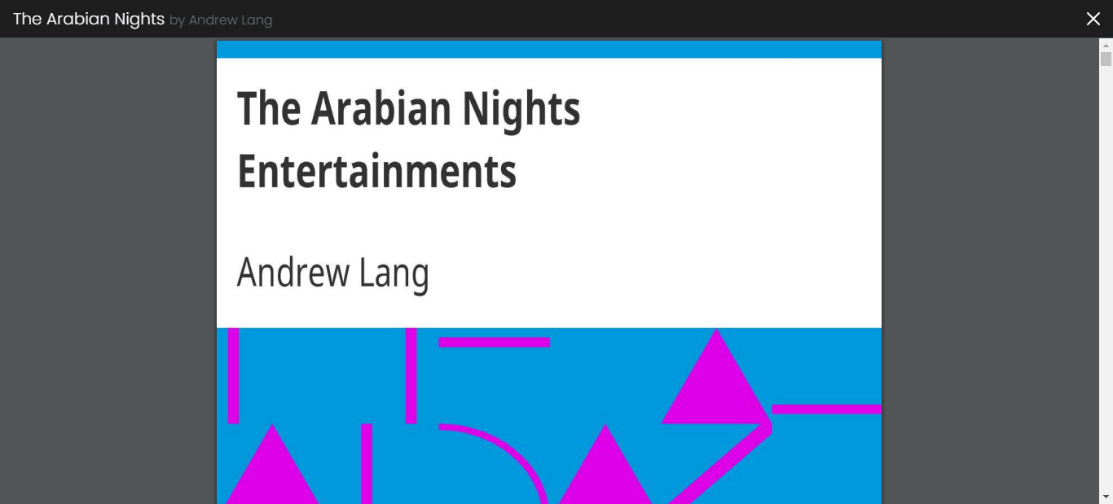

Some books are also allowed to be downloaded by the librarian.

## About & Contact pages

On these pages, you can find general information about the library like timings, no. of books available online, contact information, and location.

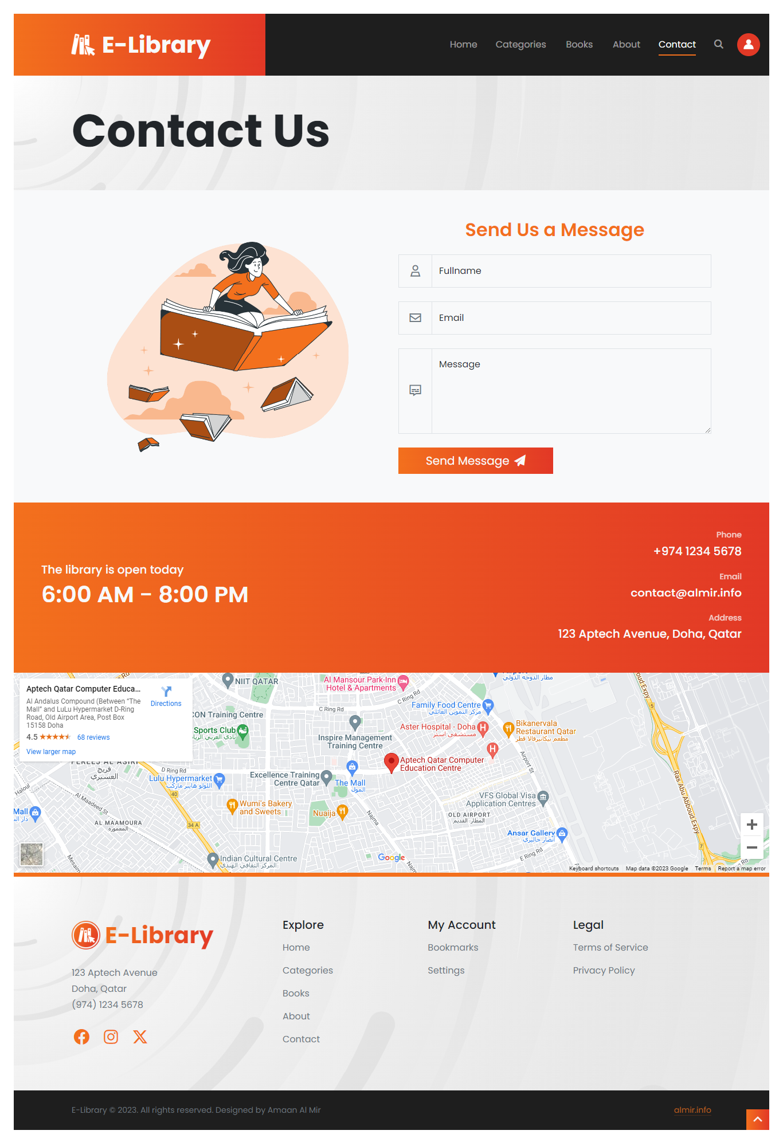

You can also use the contact form to send message to the librarian.

## User Account

On this page, you can update your account details like avatar, email and password.

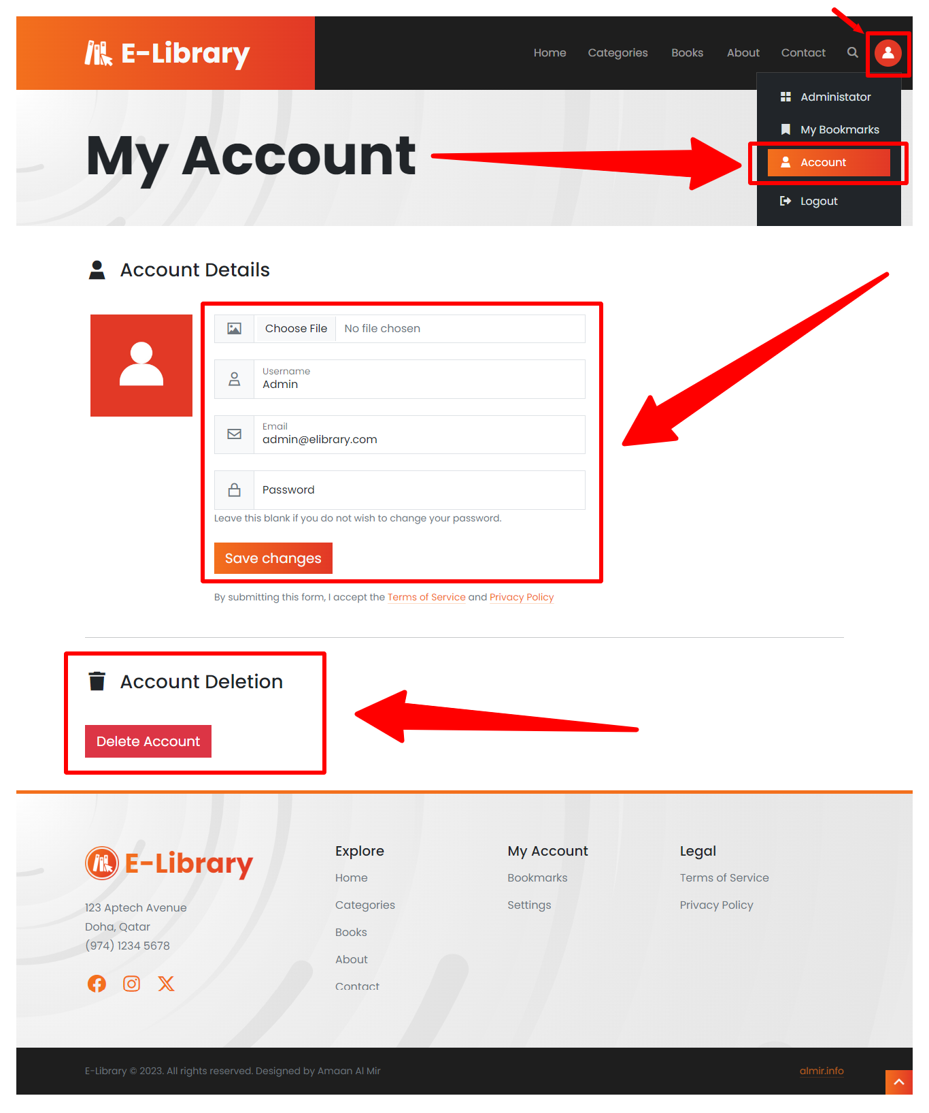

You also have the option to delete your account.

## Website Administration

The website offers administration services that can the librarian manage the E-Library’s categories, books, and users.

To go to this Admin dashboard, click on the button shown in the picture below:

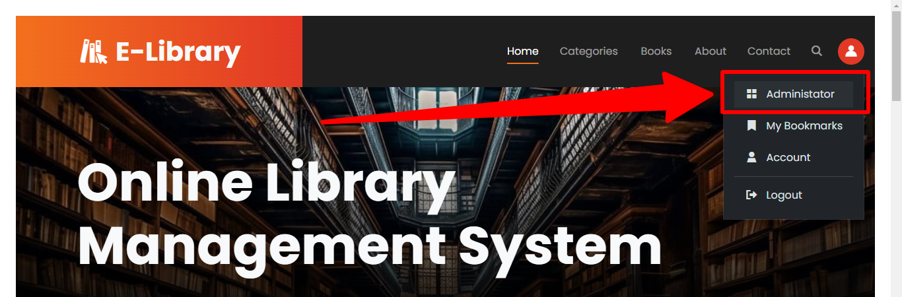

Users without admin permission will be denied access to the website administration pages.

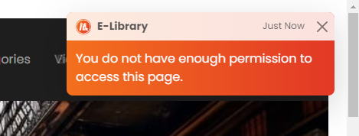

### Dashboard

On this page, admin can see an overview of categories, books, and users in the online database.

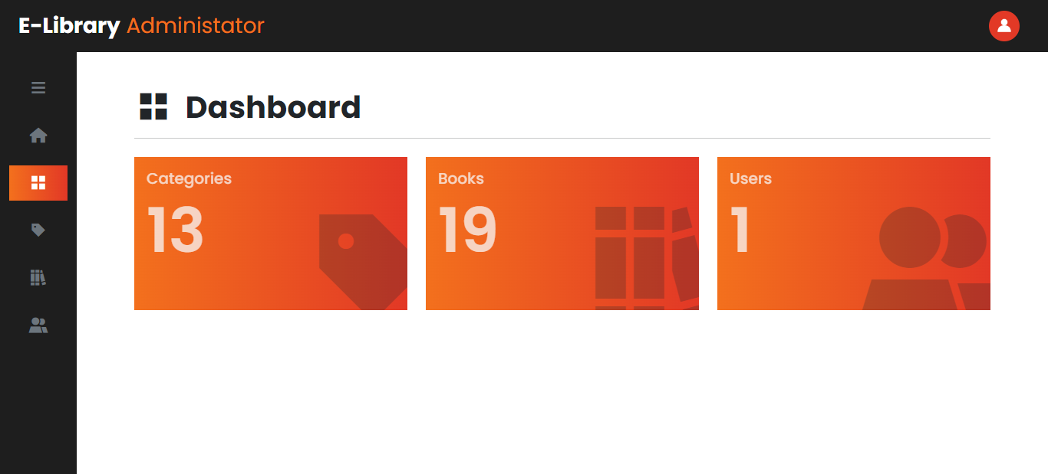

You can use side column to navigate through admin pages.

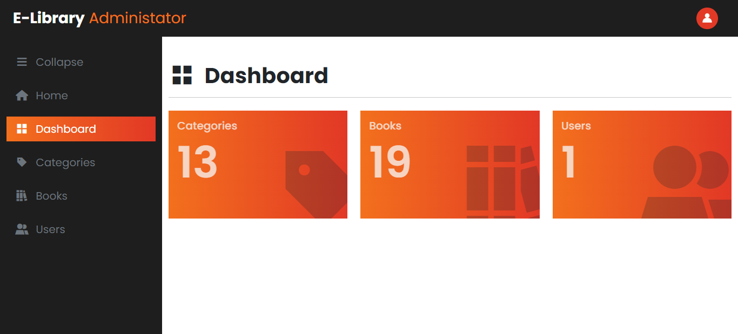

### Manage Categories

On this page, admin can create a new category or update and delete existing categories.

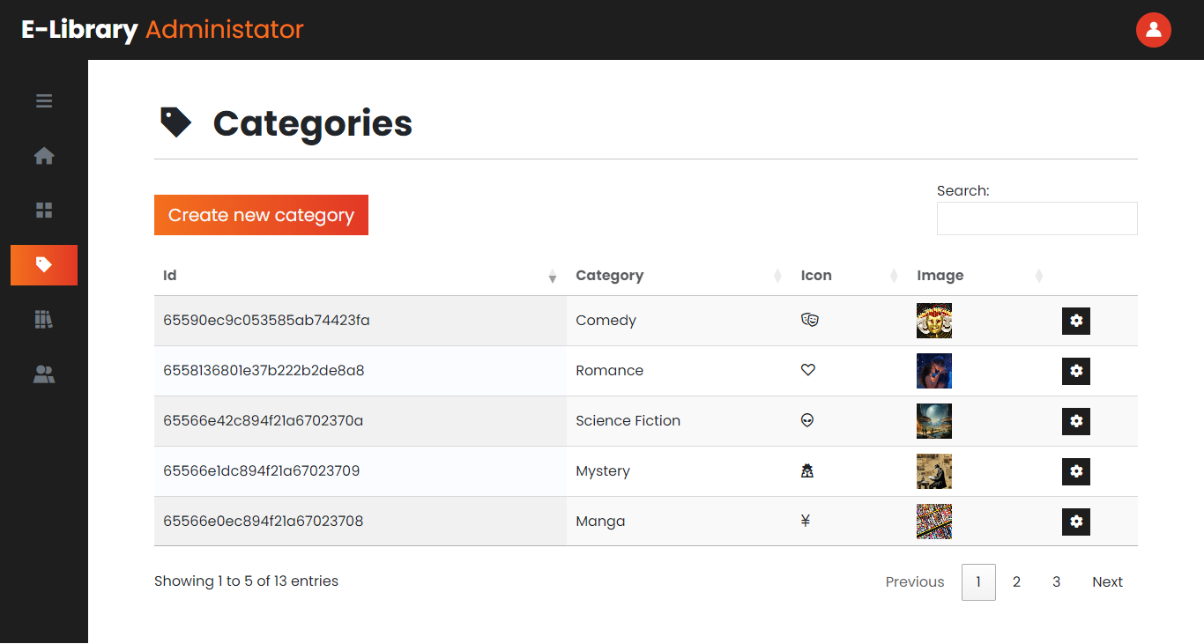

#### Create New Category

To create a new category, click on the “Create new category” button.

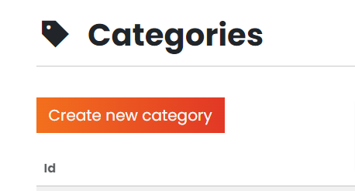

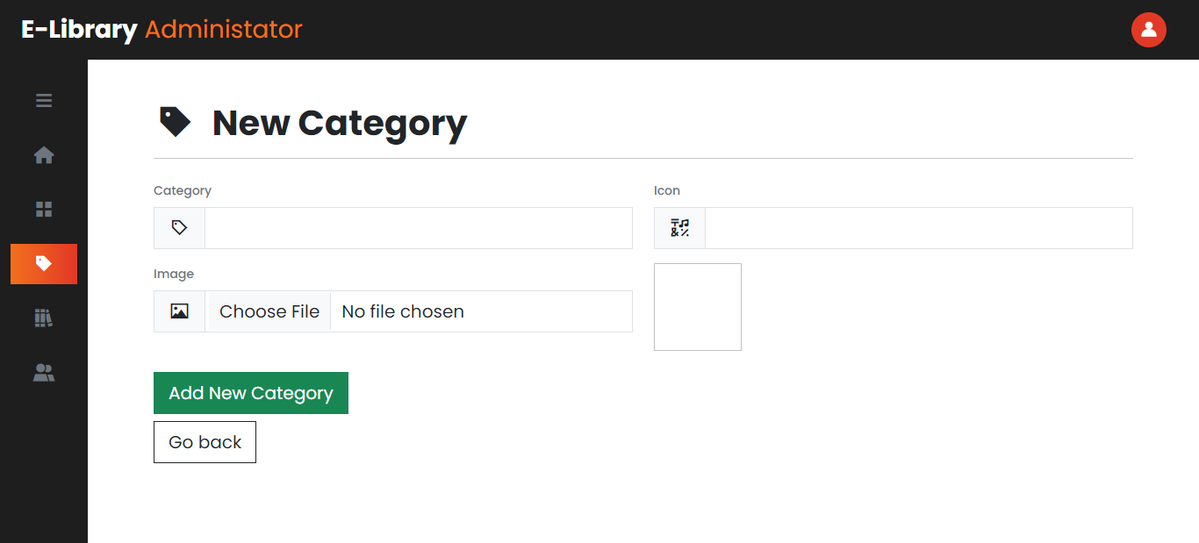

Fill the necessary details like category title, icon and an image, then click on the add button to add the category to the database.

#### Update/Delete a Category

To update or delete a category, click the gear icon next to the category to open the edit page where you can edit or delete it.

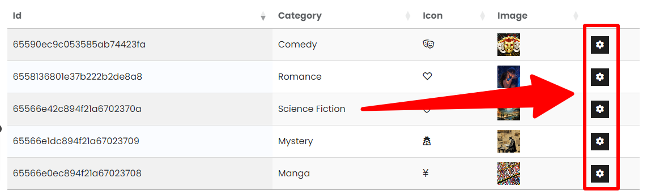

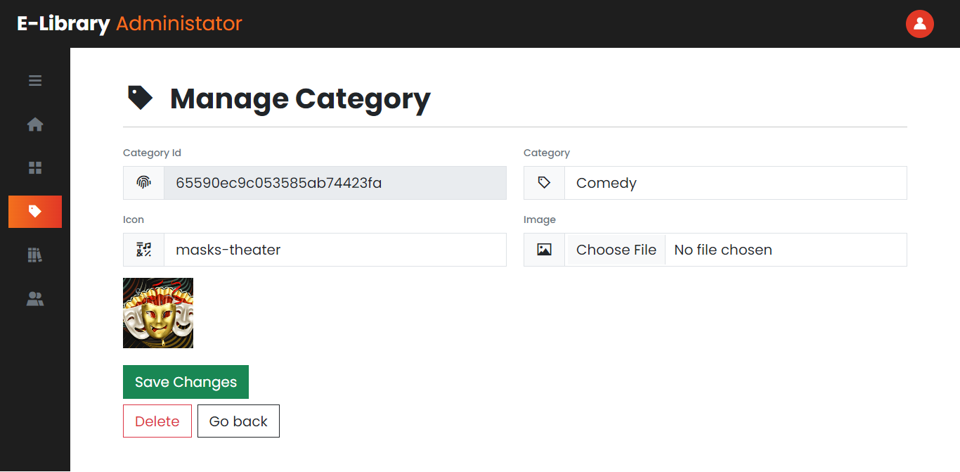

Make changes you want to make and click the green button to save them.

To delete it, click the delete button next to it.

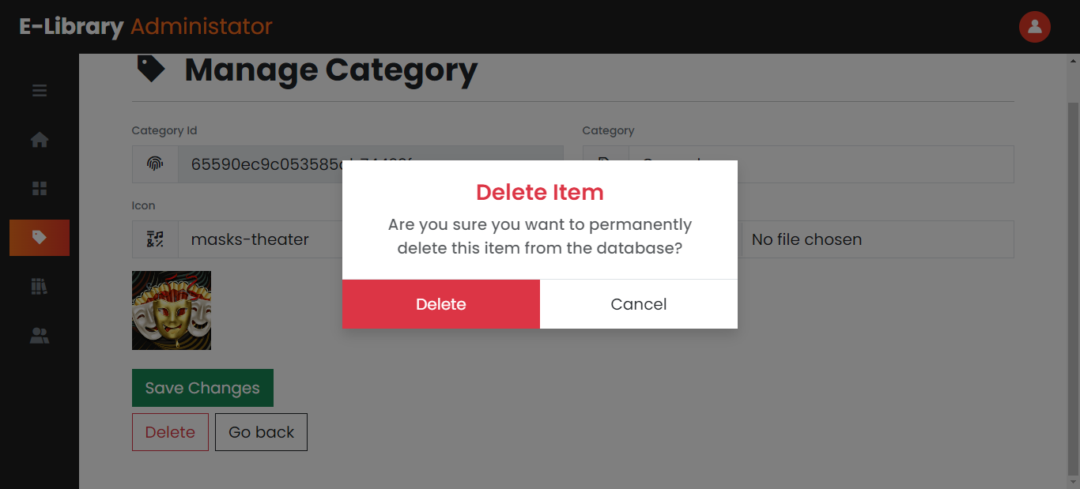

Then confirm the deletion by clicking on the delete button again.

### Managing Books and Videos

This is also similar to categories, only data is different.

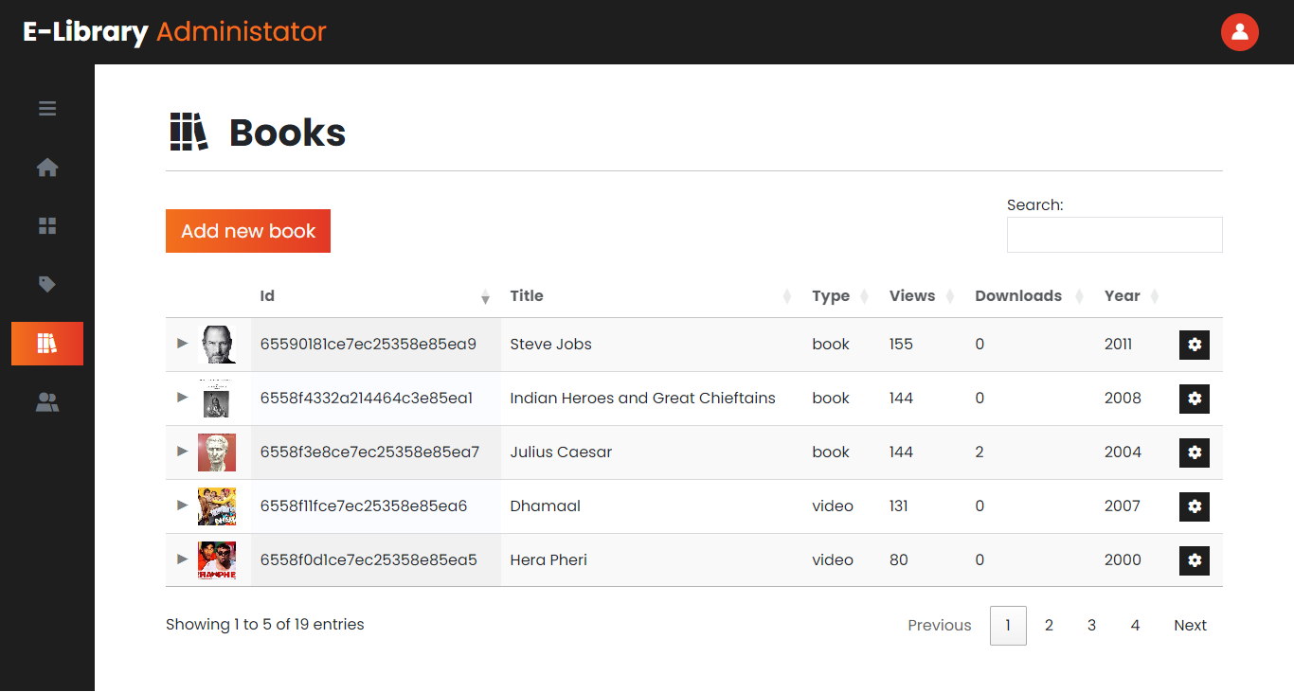

#### Add New Book or Video

Select book or video by changing type.

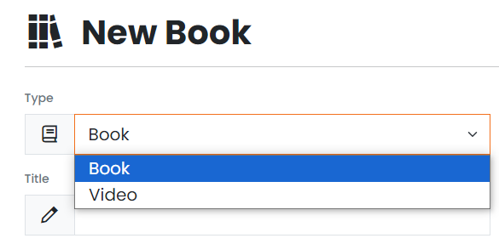

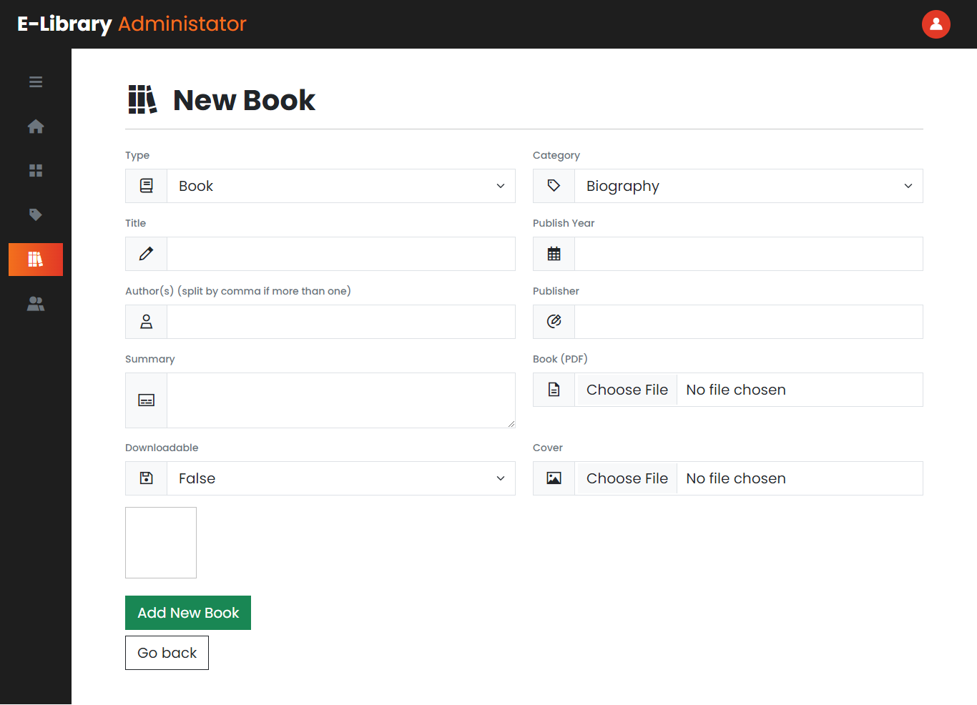

Fill up the rest of the details to add a book or a video.

Note: Only PDFs are supported for books. And for videos, enter an embed YouTube URL.

Example of an embedded YouTube URL:

<https://www.youtube.com/embed/jzYxbnHHhY4>

#### Update/Delete a Book or Video

This is similar to updating or deleting a category.

### Managing Users

Managing users is also similar to managing categories and books.

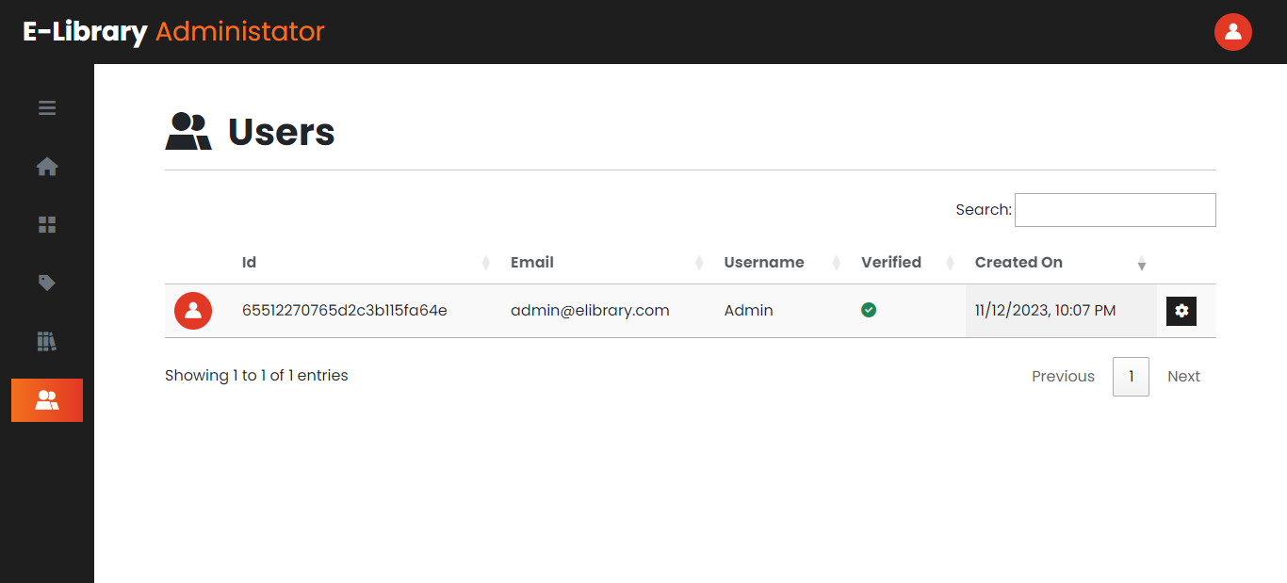

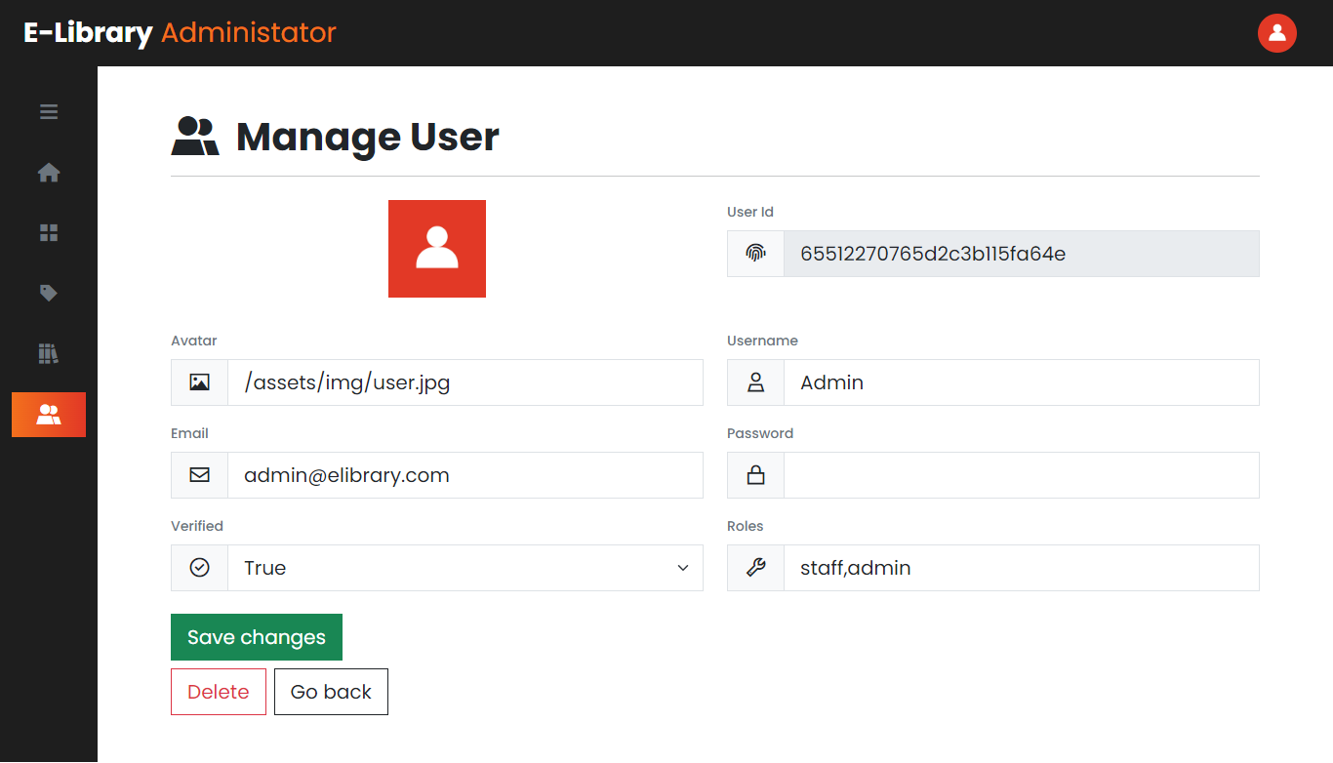

## Mobile & Tablet View

The website responsive and mobile-friendly.

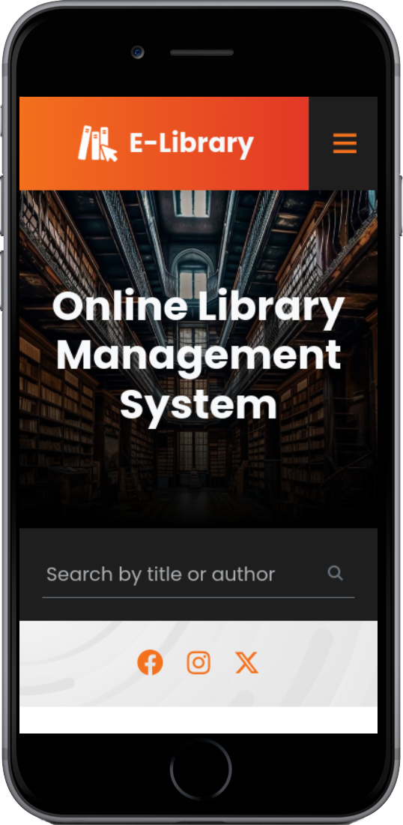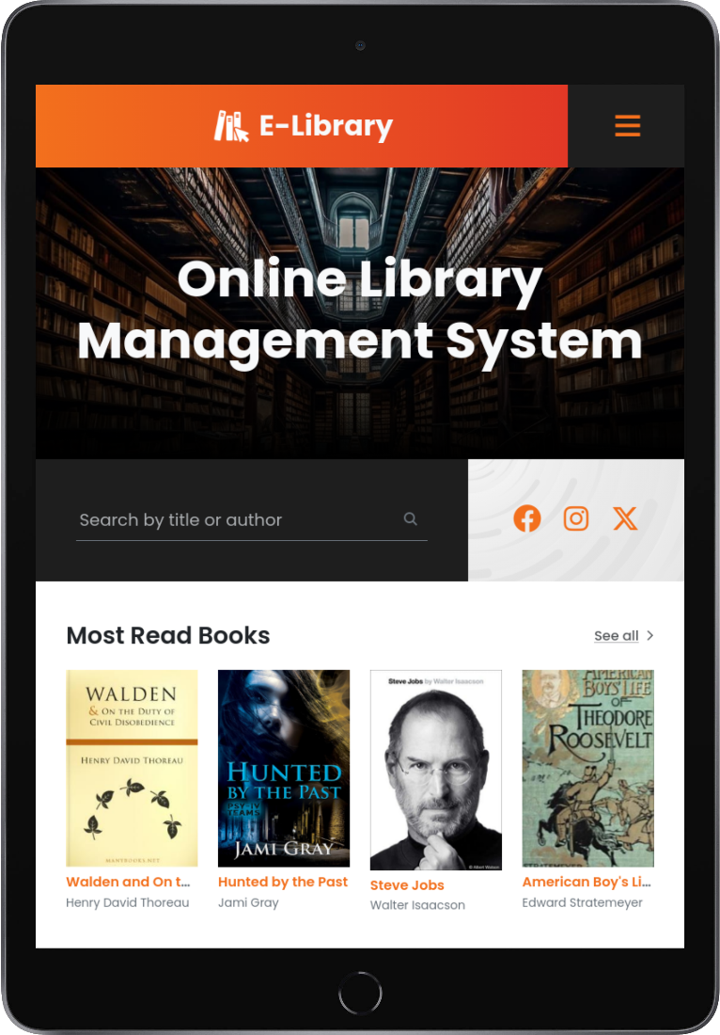

You can open the nav by clicking on the button shown below:



# Developer Guide

## Technology Stack

Frontend:

* HTML
* CSS
* JavaScript
* jQuery v3.7.1
* Bootstrap v5.3.1
* Font Awesome v6.4.2

Backend:

* Python v3.11.6
* Flask v3.0.0
* Flask-PyMongo v2.3.0
* Flask-WTF v1.2.1
* Email-Validator v2.1.0
* Flask-Mail v0.9.1
* Requests v2.31.0
* Filestack-Python v3.5.0

Database:

* MongoDB

Web Services:

* ImgBB – Image storage
  + Used to store book covers, video thumbnails, and user avatars
* Filestack – File Storage
  + Used to store books
* YouTube – Video Storage
  + Used to store videos
* Google SMTP (Mail) Server
  + Used to send email address verification and password recovery emails

## How To Run the Application?

### Prerequisites

Make sure you have the following downloaded and installed in your system:

* Python 3.9 - 3.11
* If you didn’t get the project files along with this documentation, you can download them from:

<https://github.com/BonaFideBOSS/E-Library>

* Request the config.py file from me which contains all the secrets like database connection string and APIs

### Method 1

Simple double-click on the start_app.bat file to start the application. It will take a few seconds to start up in the first run.

Note: If this is your time, it will take much longer to initialize and start up the application.

### Method 2

If method 1 fails to start the application, open CMD inside the project directory and run the following commands:

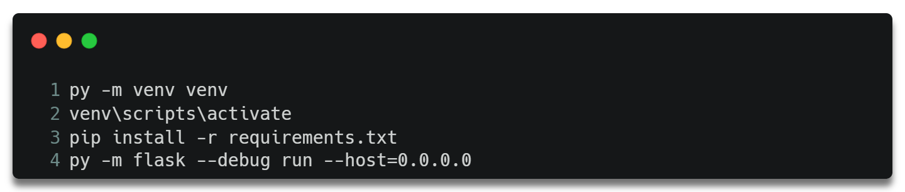

Note: Each command should be executed separately in a new line.

If successful, you should see something like this on your screen:

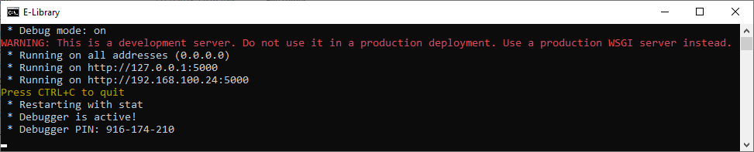

Then, simply open a browser and go the address shown in your terminal.

## Source Code

### Website Structure

|  |  |  |  |  |
| --- | --- | --- | --- | --- |
| website | | app.py | config.py | |
|  | assets  This folder contains CSS, JavaScript, and image files |  | |  |
|  | views  This folder contains HTML files |
|  | __init__.py |
|  | admin.py |
|  | admin_forms.py |
|  | auth.py |
|  | forms.py |
|  | helpers.py |
|  | mailer.py |
|  | user.py |
|  | views.py |

### Homepage

The below function is used to render the home page.

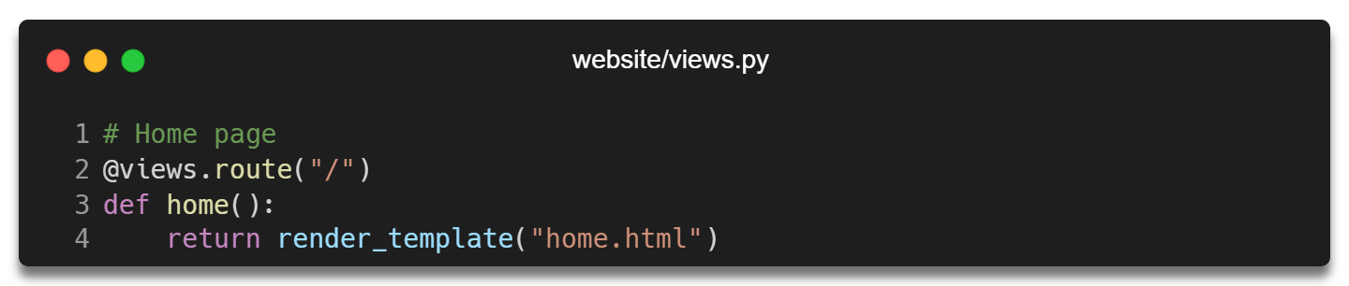

The home page also displays a list of few books and categories which are pulled through API via ajax.

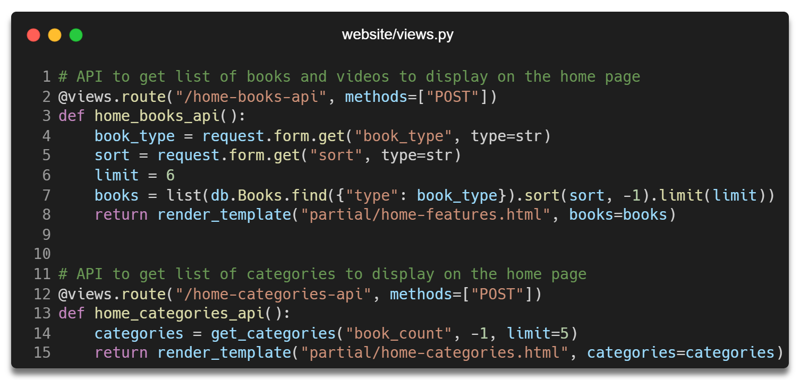

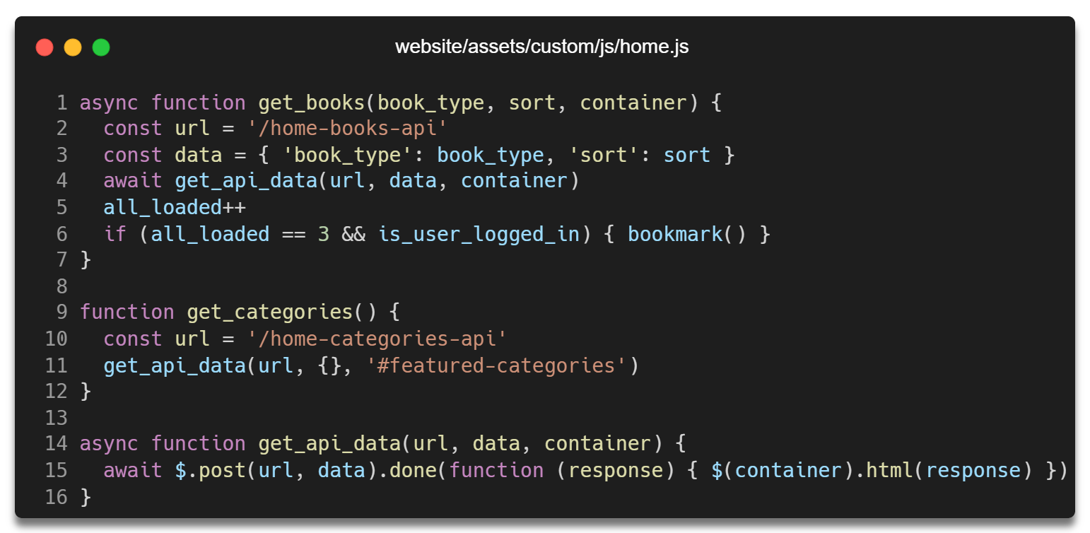

### Registration

The register form is used to render and validate the registration form you see on the register page.

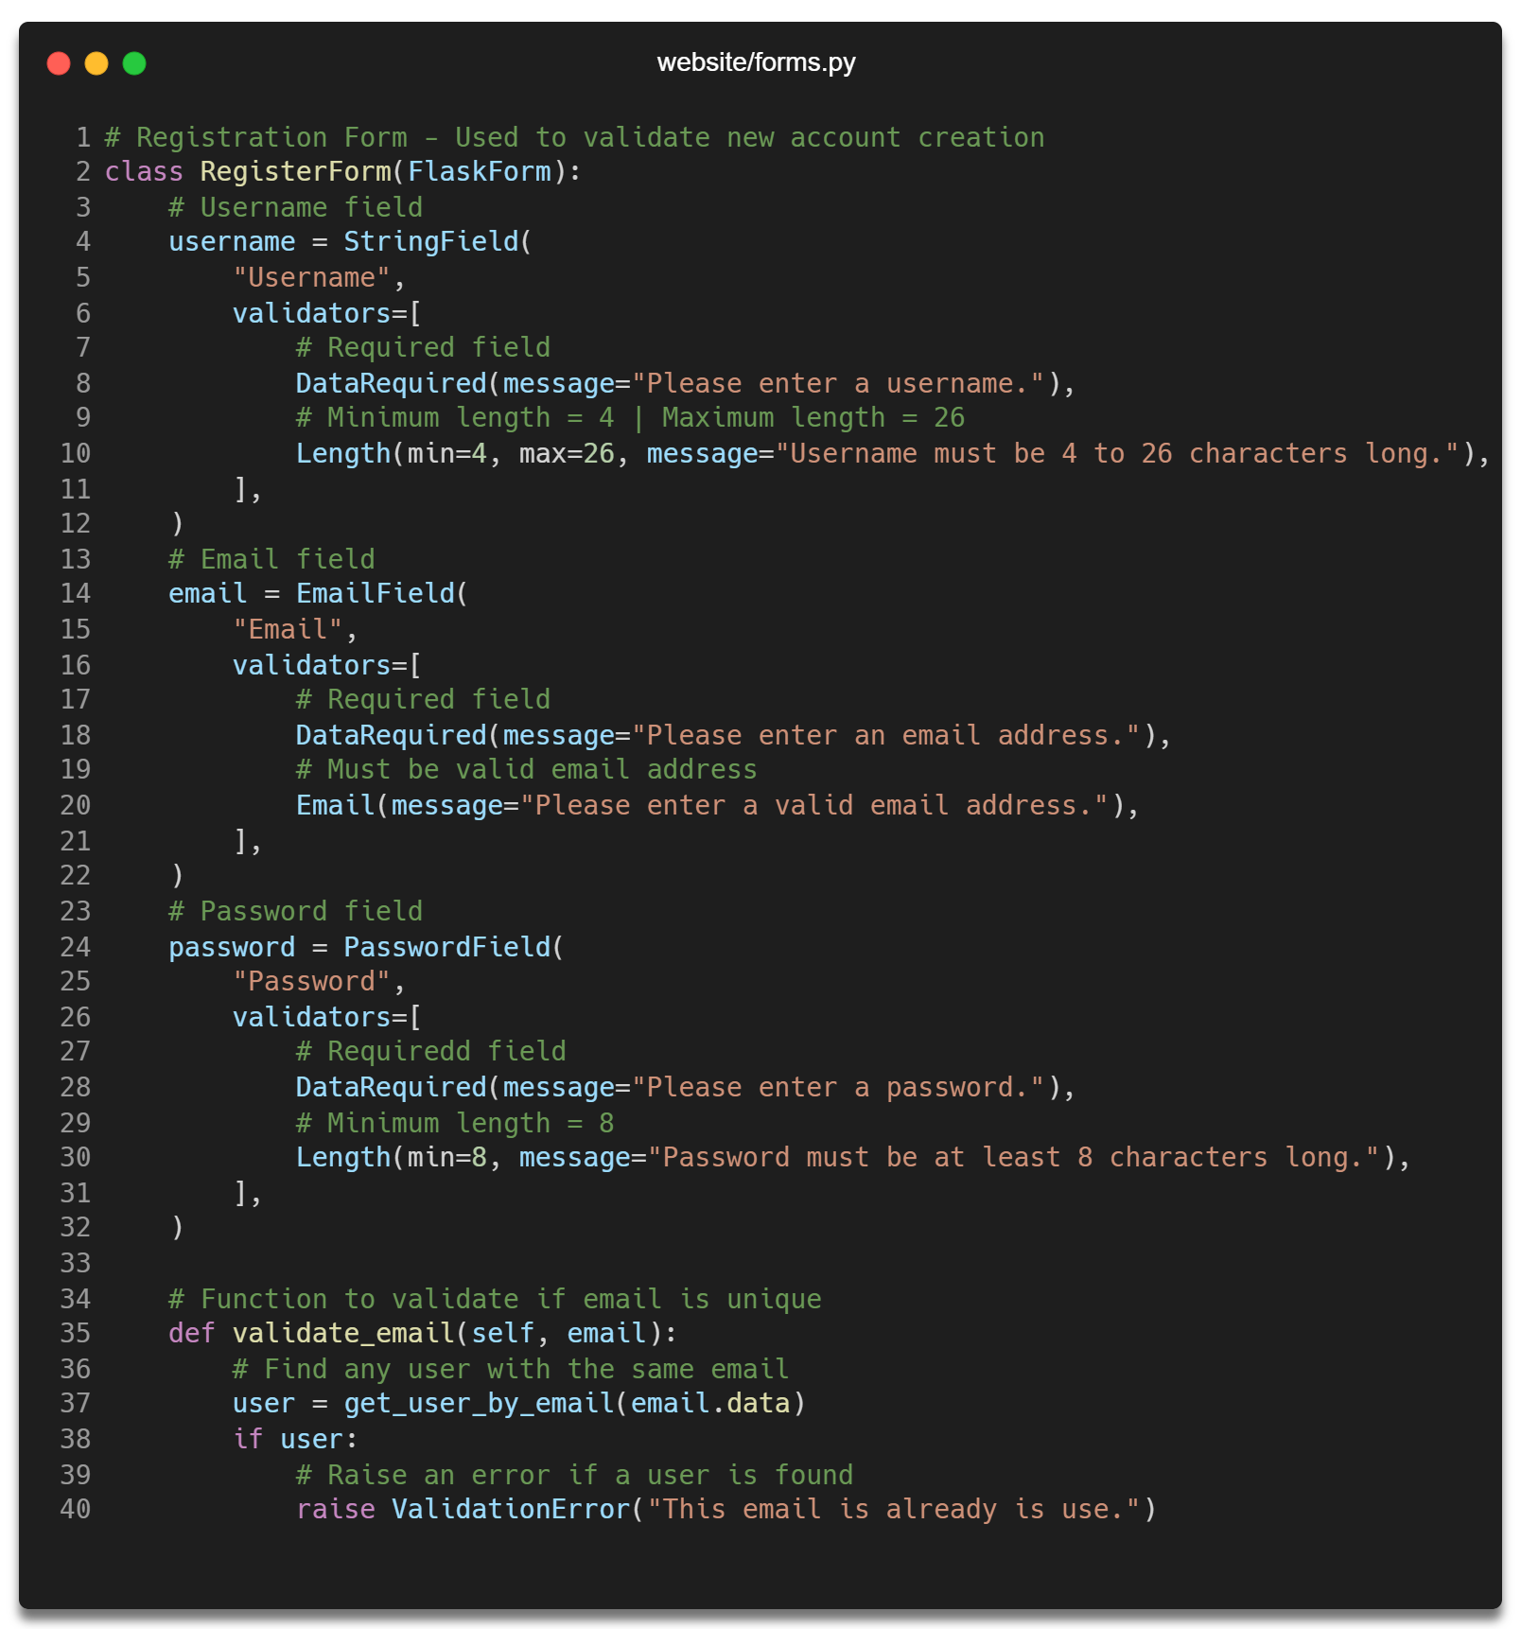

The below code is used to render the register page and validate the register form on POST request.

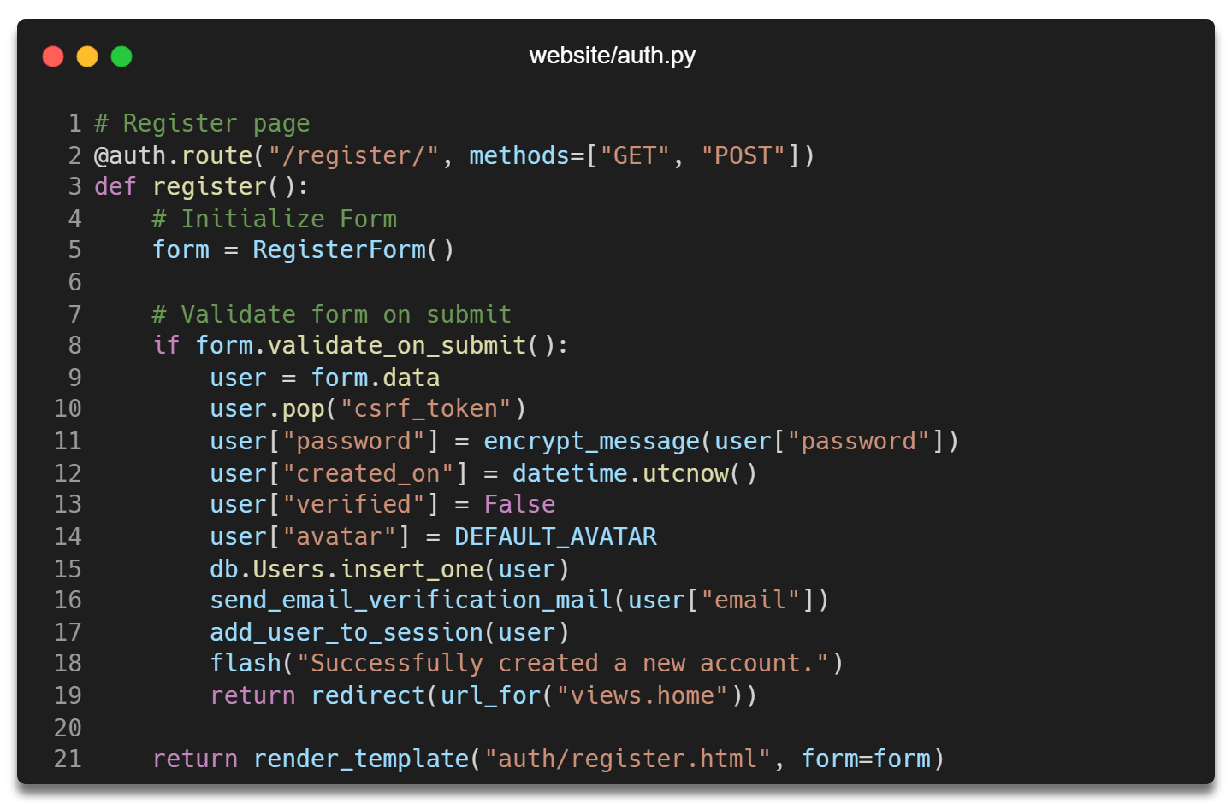

The below function is used to mail a verification link after user successfully creates a new account.

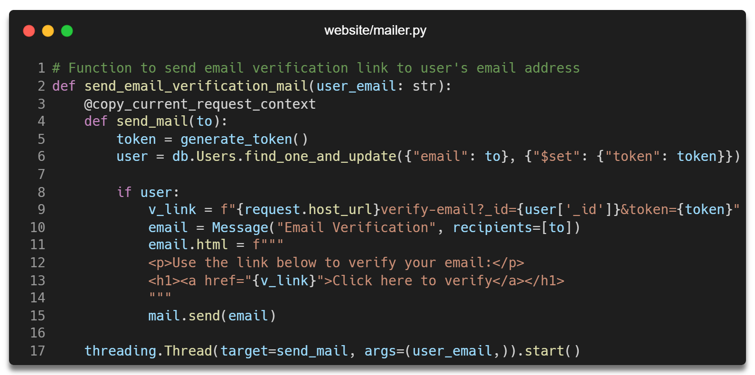

### User Login

The below code is used to render the login page.

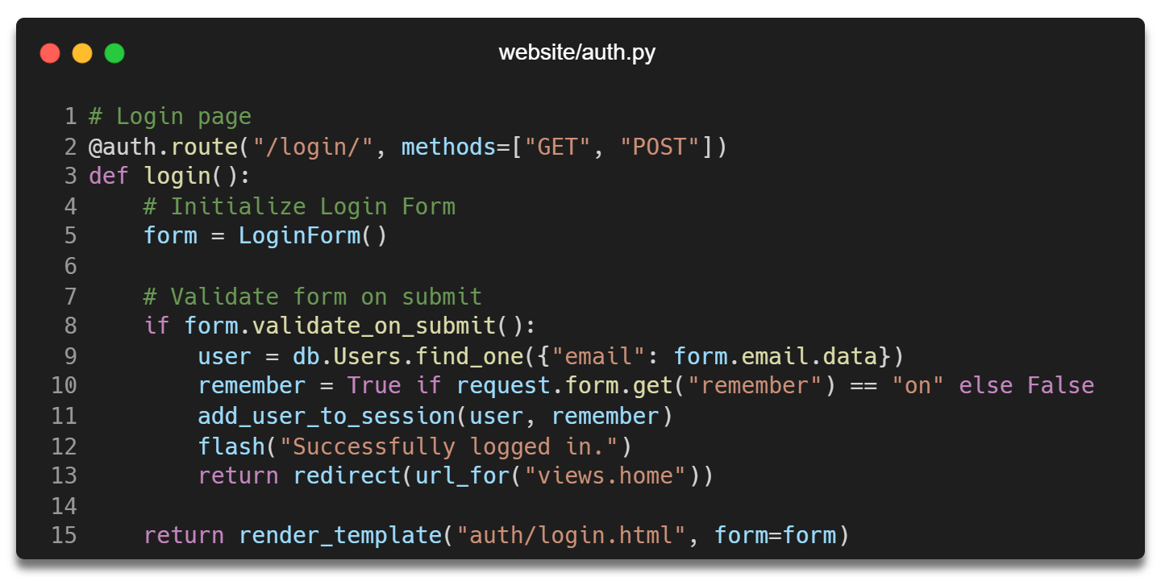

The login form is used for rendering and validating the user login form passed to the login view.

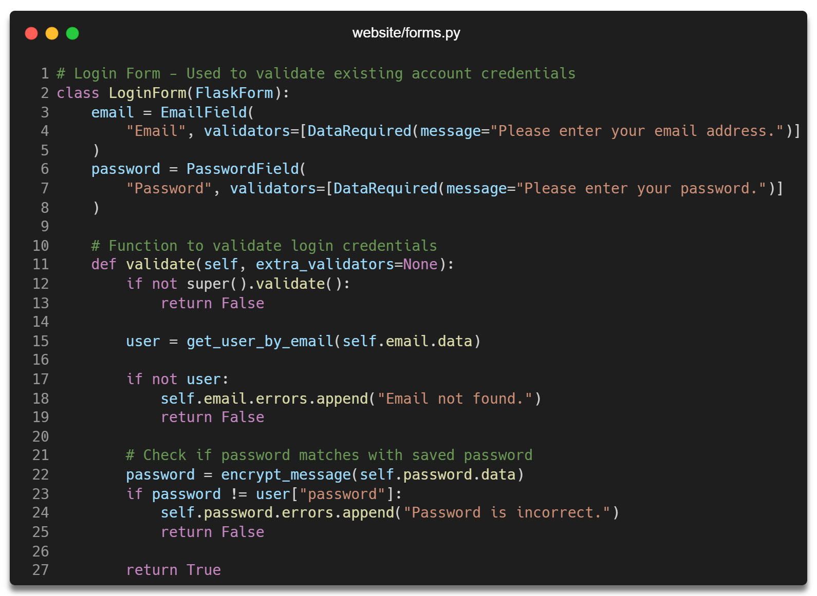

After successfully logging in, the user is added to the session using the below function.

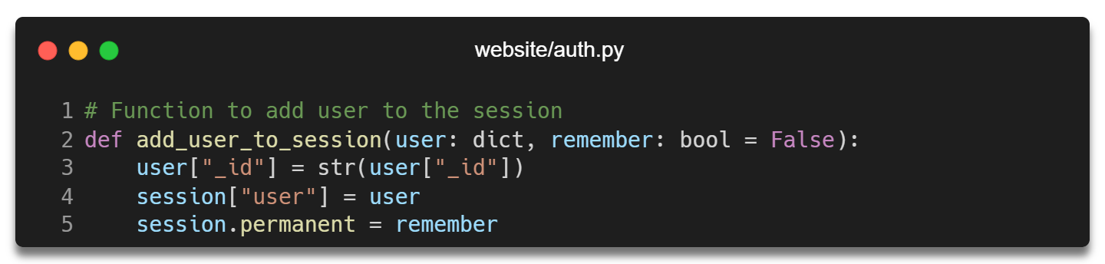

### Password Recovery

The below function is used to render a page to let user submit a request to reset their account password.

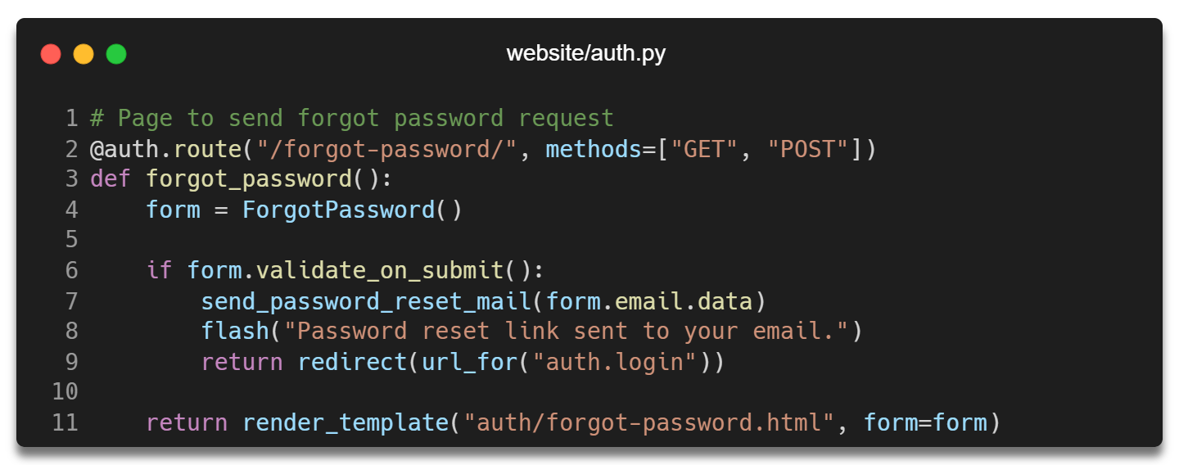

#### Mail

The below function is used to send a password recovery mail to the user.

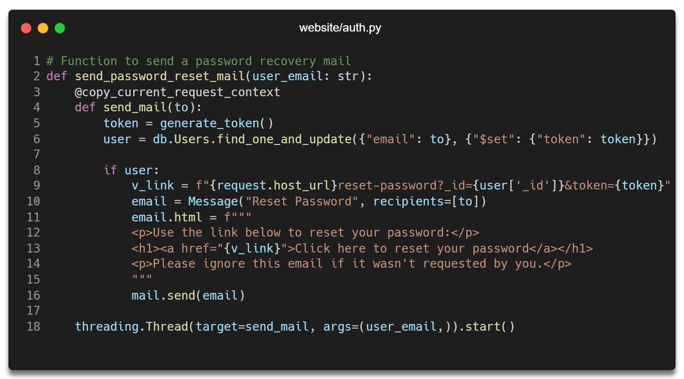

#### Reset Password

The below function is used validate the password recovery link and allows user to reset their account password.

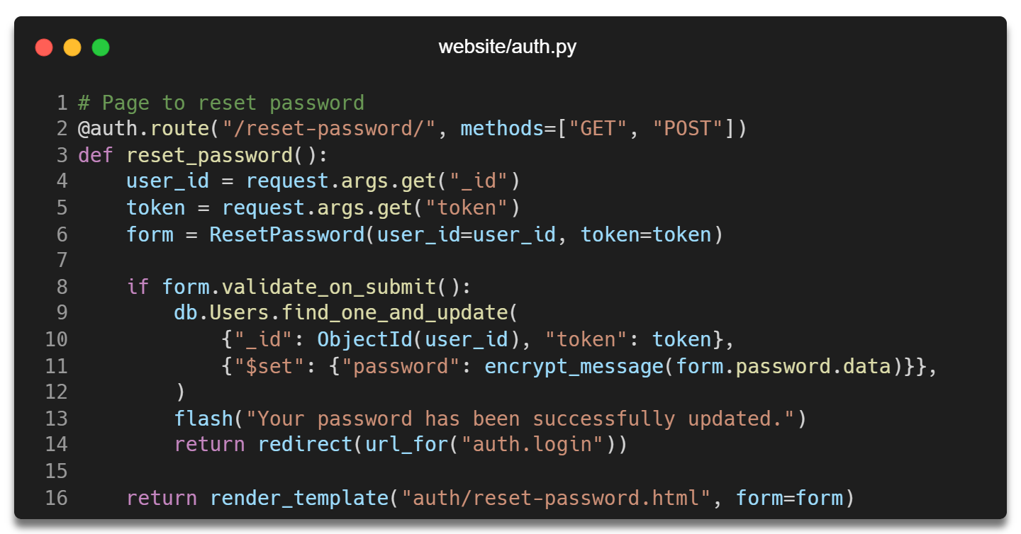

The forms used to validate user inputs are inside the forms.py file.

### Categories

The below function is used to retrieve a list of categories along with the number of books in each of them.

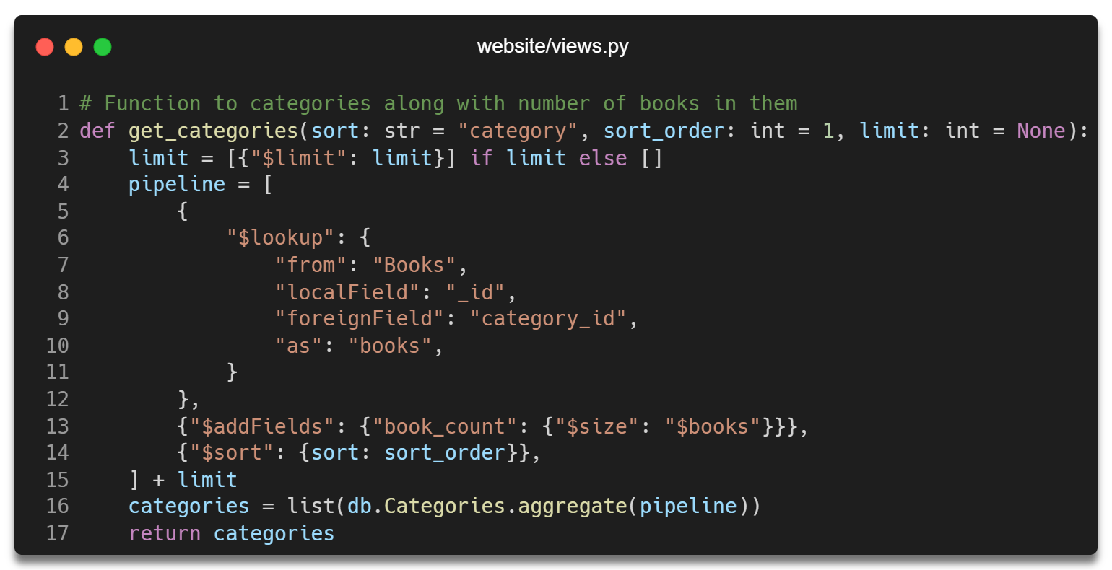

Then, the below function is used to render the categories page.

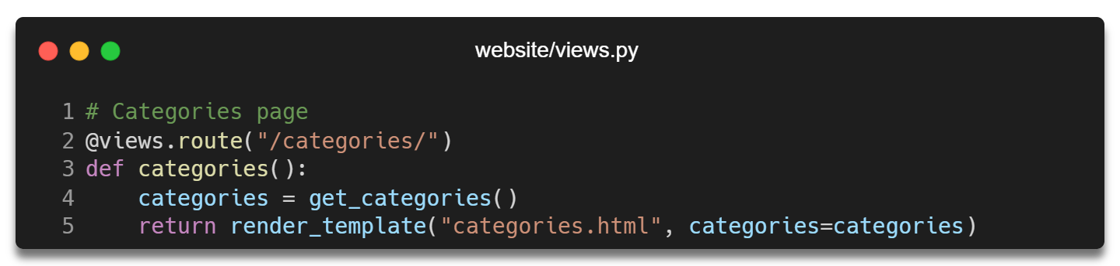

### Books

The below function is used to retrieve a list of books and videos from the database and render the books page. The search function is also included in this code.

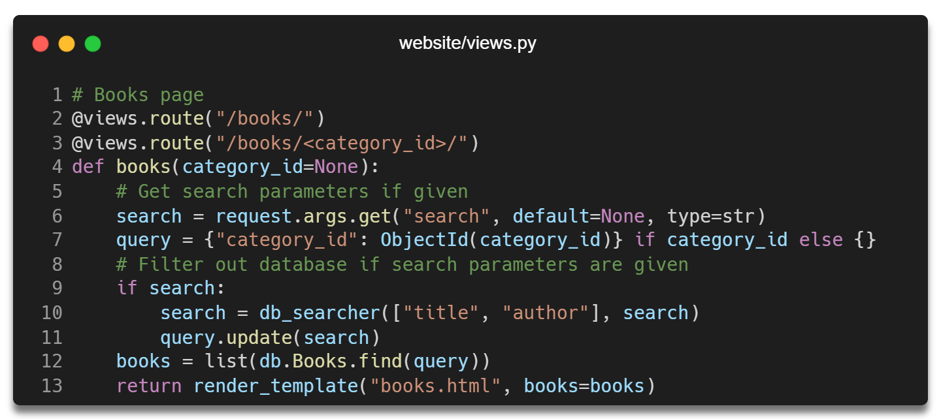

### Book Details

The below function is used to display the details of a book.

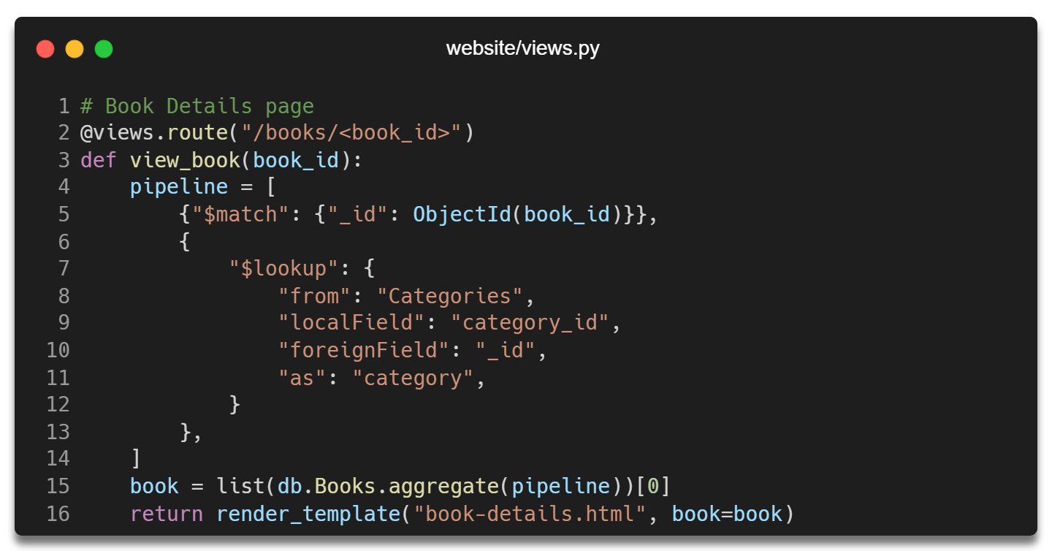

#### Download

The below API route is used to let users download a book.



#### Updating Book Stats

The below function is used to update a book or video view and download count.

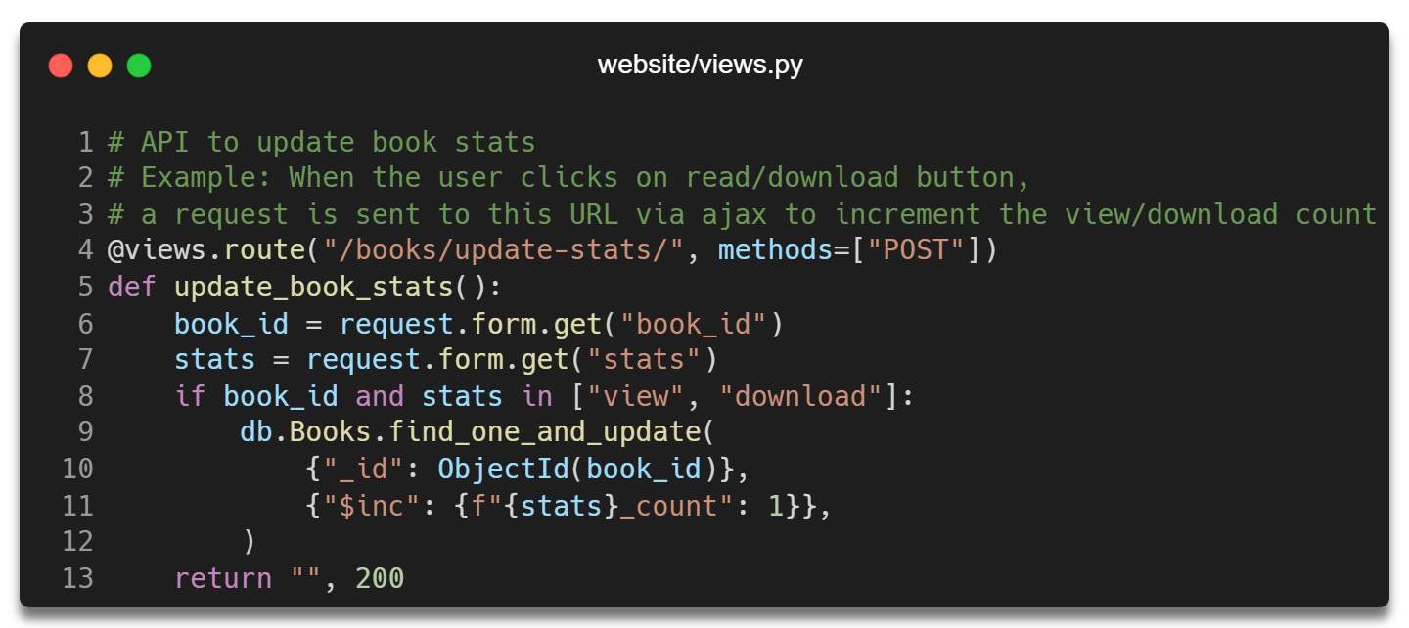

### User Account

The below function is used to render the user account page and process user details on POST request.

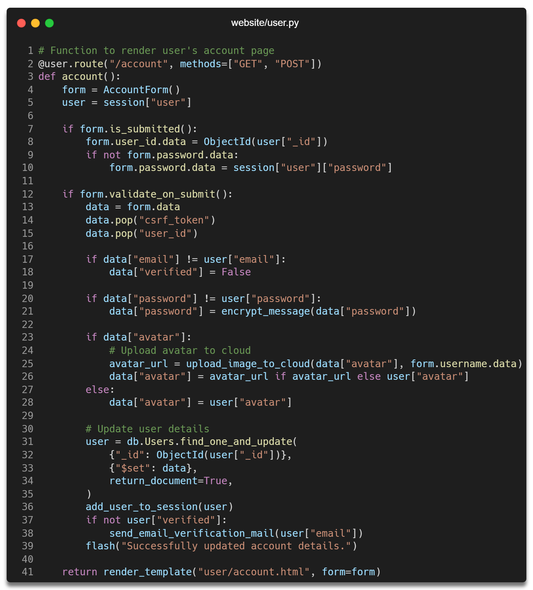

### Website Administration

The admin functions are located inside the admin.py and admin_forms.py files.

#### User Permissions

Before every request, the below function is used to check if the user has admin roles.

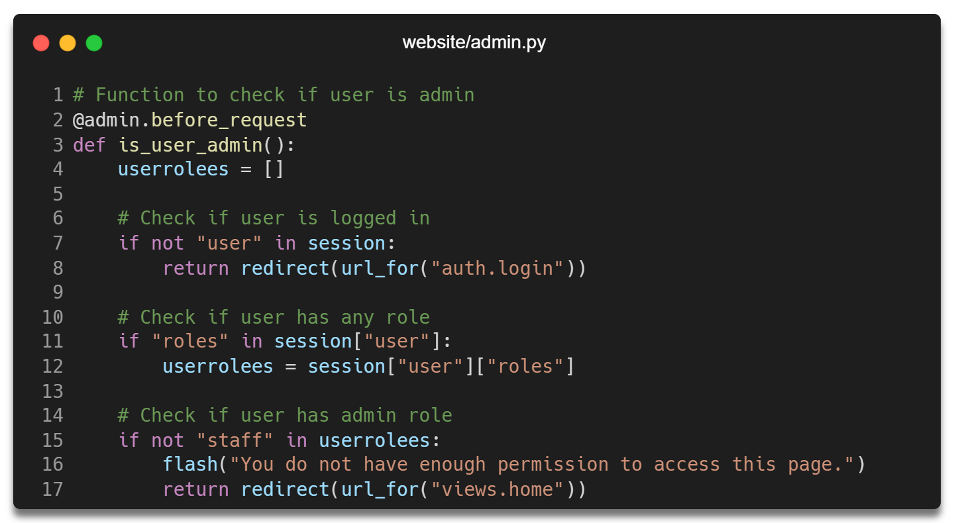

If the user does not have the required role, they are redirected to the homepage.

#### Role Authorization

Not all users who can view the admin dashboard are permitted to use all features of the website.

For example, any staff can create a new record, but only an admin can update or delete an item from the database.

The below function is used to authorize certain roles before the start of any function.

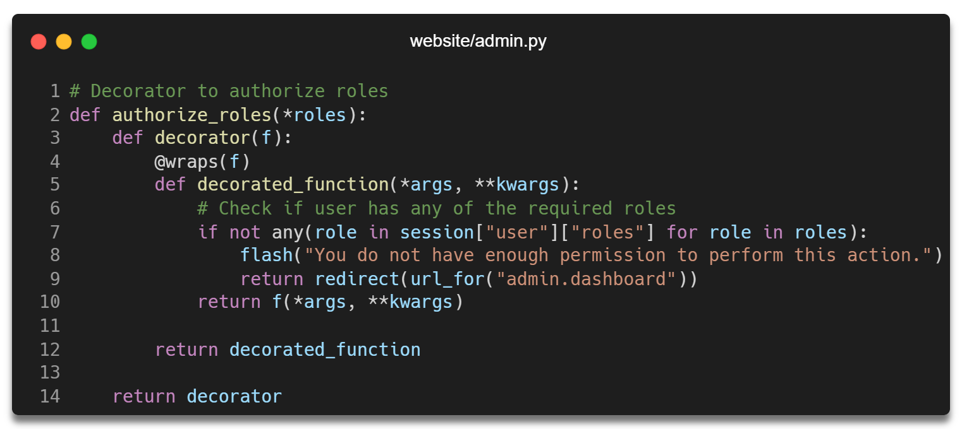

#### Insert Records

All admin pages perform a similar method of processing data. This documentation only includes the processing of Books.

The below function is used to render the page where the admin can add new books or videos.

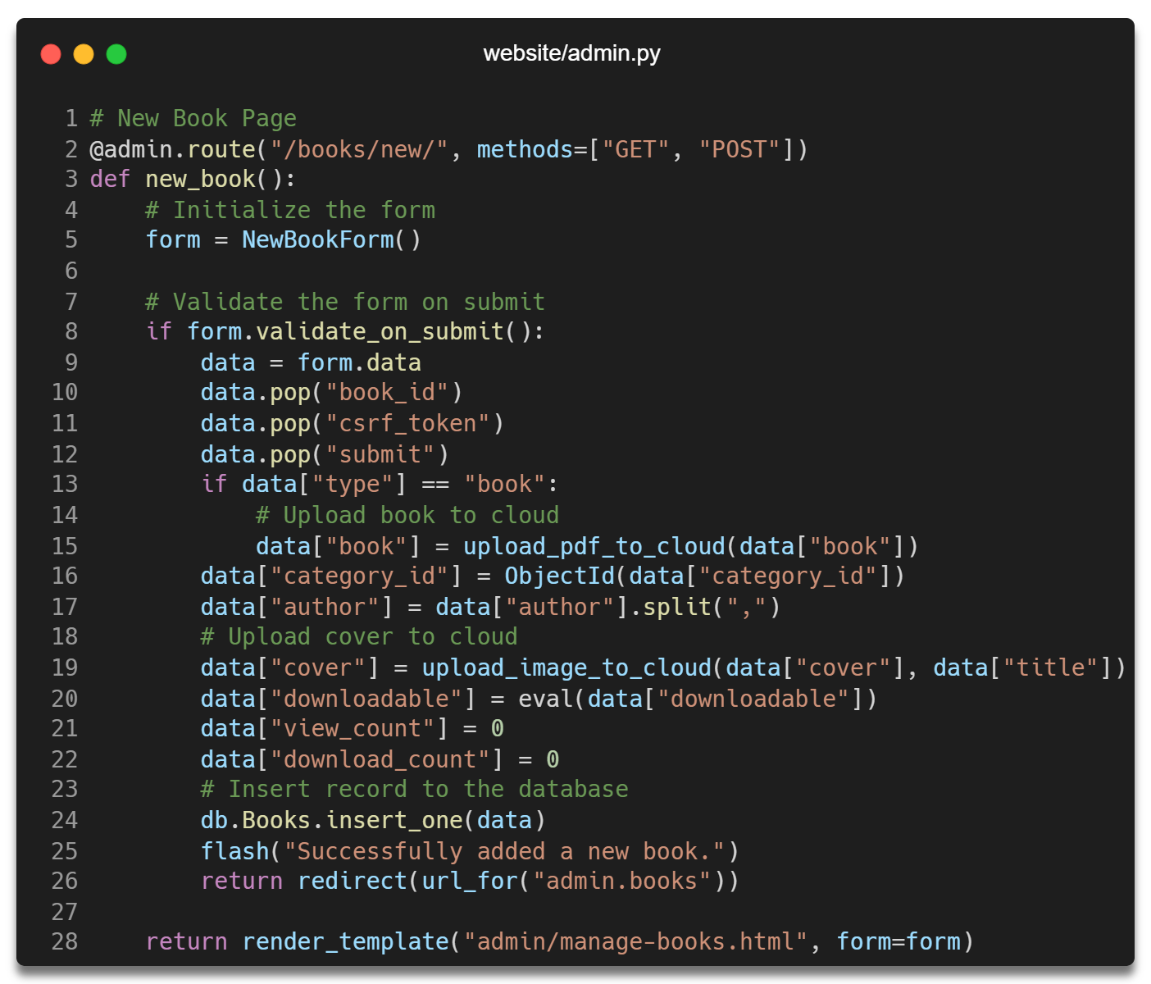

The below form is used to validate book details.

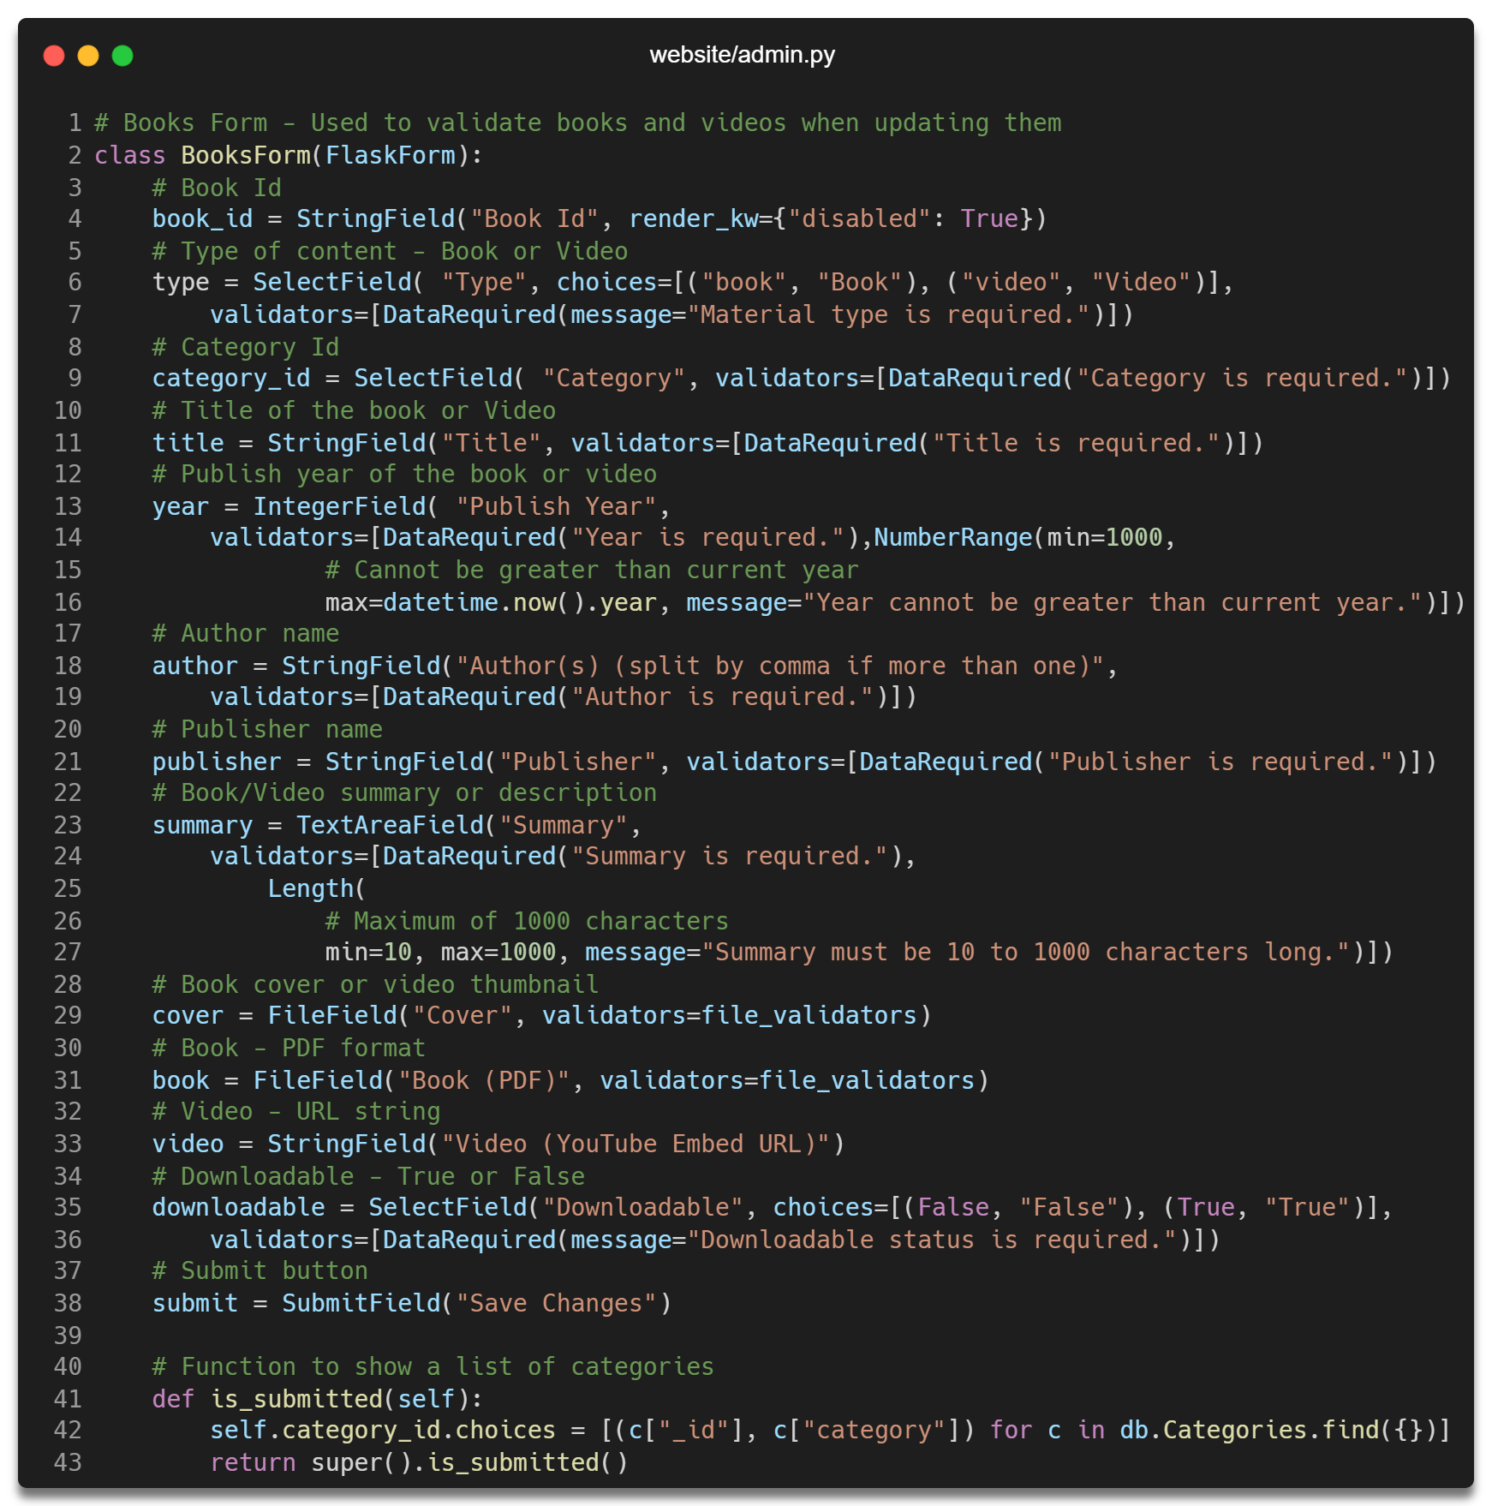

#### Update Records

The below function is used to update book details.

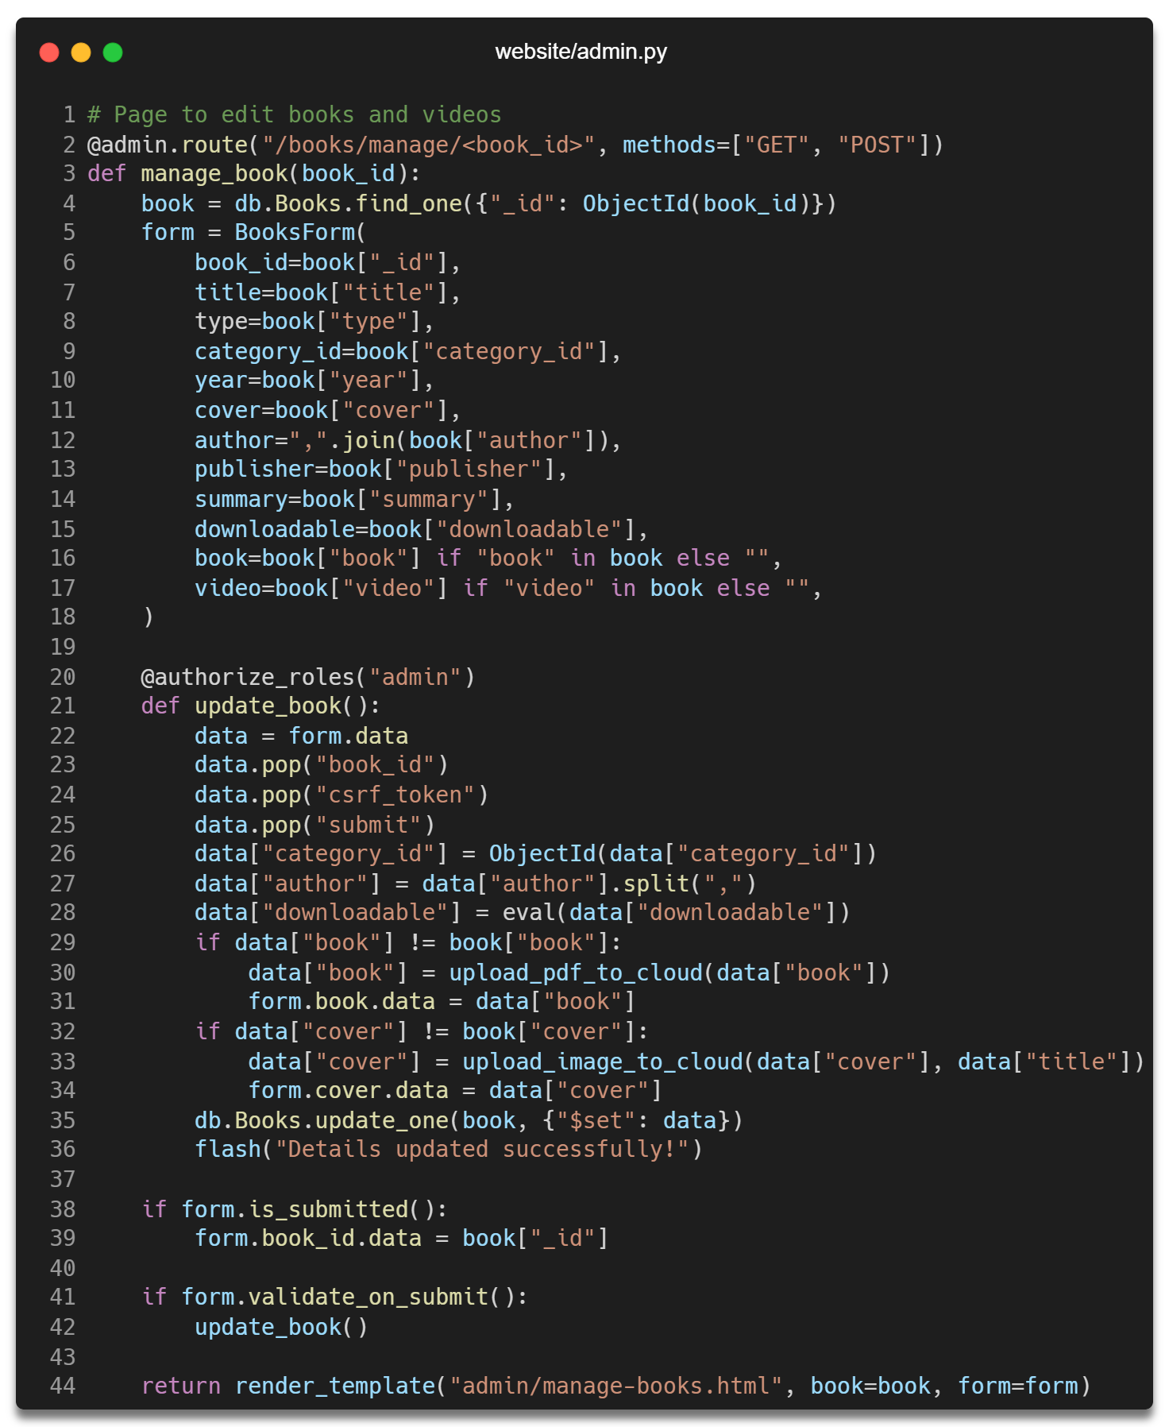

#### Delete Records

The below function is used to delete a document from the database.

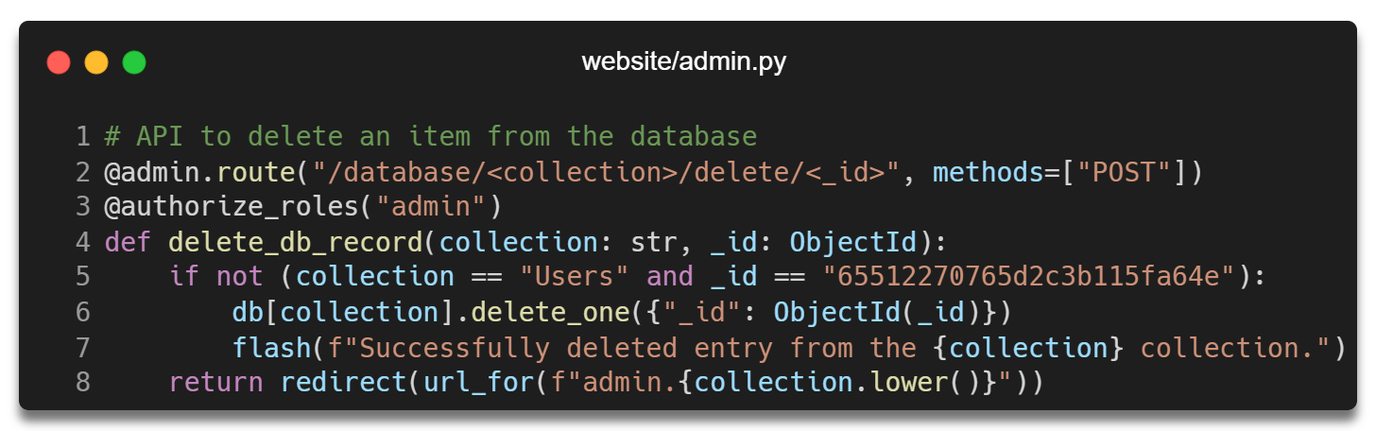

#### View Records

The below function is used to retrieve data from the database and send them to admin dashboard.

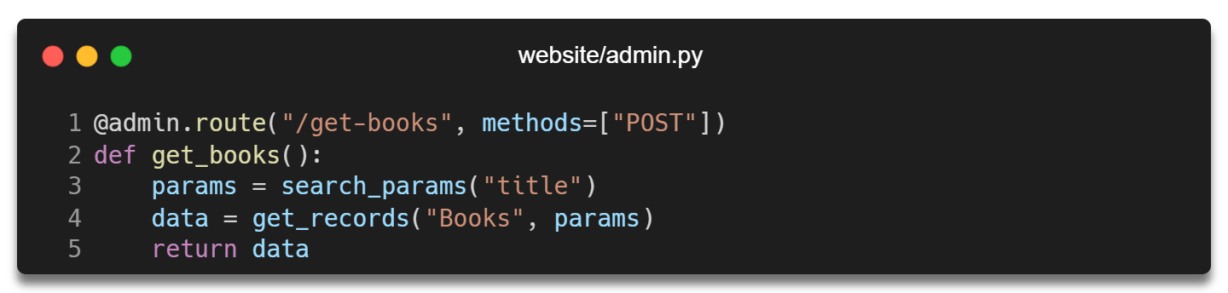

Datatables server-side rendering feature is used to pull the data from the above URL and display them in a tabular format to the admin.

# References

Anon., n.d. *How to Set Up Flask with MongoDB.* [Online]   
Available at: https://www.mongodb.com/compatibility/setting-up-flask-with-mongodb  
[Accessed 2023].

Lord, D., 2023. *Flask Documentation.* [Online]   
Available at: https://flask.palletsprojects.com/en/3.0.x/

Otto, M., 2023. *Bootstrap.* [Online]   
Available at: https://getbootstrap.com/docs/5.3/